THE REMER BROTHERS
AND THEIR DESCENDENTS

Researched and Compiled by Donald Harry Moore
Great-Grandson of Charles (Karl) REMER

Edition: September 2021.
This will be updated as more information in known.

2 Part One: From Bavaria to the USA
5 Part Two: An Overview of the Brothers in the USA
9 Part Three: Samuel and his descendents
19 Part Four: Charles and his descendents
24 Part Five: Michael and his descendents
31 Addendum One: The Grave of Victoria Essigkrug Remer Kunzmann
32 Addendum Two: Articles and Obituaries of the Samuel REMER line
36 Addendum Three: Articles of the Michael REMER line
37 Subject For Future Research
38 Selected Links

Lots of old street addresses for where people lived and worked are included here. Street numbers were reset at least once in the late 1800s. Some addresses and names also changed when the old city of South Omaha was annexed into Omaha in 1915. For example today’s 13th Street was once 15th Street. So modern street numbers are close to, but not exactly where the old ones were.

Part One
From Bavaria to the USA

Our REMER ancestry comes from three brothers who came to the United States in the late 1800s. First to arrive was Samuel in 1878, then Charles (Karl) in 1881, and finally Michael in 1884. Those are the years of arrival that the three men put on later census records. No actual records of Samuel or Michael’s departure from Germany or arrival in the USA have been found. Charles is probably the Carl REMMLER, age 17, laborer, who on 1 August 1881 arrived alone in New York from Hamburg on the Vandalia. That corresponds with his time of arrival, his age, and the fact that we know he came alone.

But what do we know about their family background in Germany? Unfortunately, not a lot. My uncle, Charles Richard MOORE, told me some things that his grandfather, Charles REMER, told him. They were from Bavaria. The boys’ father, a butcher, was killed in an accident while they were young and their mother remarried a man named KUNZMANN. The three boys did not get along with their step-father and decided to come to the USA. Samuel, the oldest, came first. He sent money back to help pay for Charles and, in turn, Charles helped pay for Michael’s passage. They also had a sister who married and stayed in Germany. In 1891 the sons paid for their mother, Victoria, to come from Germany on an extended visit. Passenger records show that Victoria (age 59) and John (11) KUNZMANN arrived in New York City from Bremen on the Eider on 6 October 1891. John was a mentally-retarded half-brother. Victoria died in Omaha on 25 July 1892 and is buried in the Mary Magdalene Cemetery in Omaha. John’s father wasn’t willing to pay for his return and none of the three adult REMER brothers were willing to care for him. According to Uncle Charles, John was placed in an institution in Omaha and died there a few years later. Aside from the passenger list, no record of him has been found.

The REMER Name

REMER is one of several similar German surnames, including RIMER, REIMER, ROEMER, and RAMER. None of these surnames are particularly common. Sometimes immigrants altered the spelling of their surname after arriving in the new land, but I believe that REMER is how the family spelled it in Germany as all three sons consistently spelled it that way in the USA. Nevertheless, members of the family occasionally appear in the records under one of the other spellings. That’s probably because the clerk recording the information didn’t bother to ask about spelling.

Of all the spelling variations, REMER is the most uncommon version in the United States. In the 2010 census there were fewer than two thousand people with that last name in the entire country. In comparison, there were nearly four thousand people named REIMER, nine thousand named ROEMER, and sixteen thousand named RIMER.

In researching our REMER line, an important thing to know about names is that individuals often went by their middle names and not their first names. For example, the eldest brother, Simon Samuel REMER, almost always appears in the records as Samuel, but occasionally appears as Simon, or Simon S. or S. S. or even Samuel S. The name on his tombstone is Simeon S REMER, although the name is not spelled with an ‘e’ in German. Generally I refer to individuals by the name they commonly went by or else by the first + middle name when there’s a need to avoid confusion between two people who go by the same name.

The Parents

The best information we have on the three sons’ parents comes from their marriage licenses. All three list their father as John REMER. It would have been Johann in German, but the English-speaking clerks probably just wrote what they heard. (That’s also probably why the name is misspelled as ROEMER on Simon Samuel’s marriage license.) According to my Uncle Charles, the father was named Samuel, so I suspect he was actually named Johann Samuel REMER.

Victoria’s maiden name is a mystery, despite it appearing on the marriage licenses of all three sons. Her first name would have been Viktoria in Germany, but all three clerks spelled it the English way. On Samuel’s license her full name looks like ‘Victoria Essigkrug.’ On Charles’ license the name appears to be ‘Victor Krug.’ For Micheal there are images of both the affidavit for the license and the license itself and the penmanship is very clear. In both places the name is clearly written as ‘Victor Essegkrug’.

It’s strange that her first name was written as ‘Victor’ on two licenses. Maybe that’s the way the clerks heard the name spoken. More interesting is the different versions of her maiden surname. Some other researchers of the line have transcribed the name as ‘Eisenkrieg’ or ‘Essenkrieg’. However, in comparing the letters in the name with the penmanship used to write the same letters in other words on the licenses, it is clear that the name is ‘Essigkrug’ on Samuel’s license and ‘Essegkrug’ on Michael’s.

Krug is common German surname but the other two seemed odd to me so I asked a German friend who lives in Bavaria. He did some searches in the online all-Germany phone directory. There was not a single listing for Essegkrug. However, there were a few listings for Essigkrug, all scattered across southern Bavaria. So most likely Viktoria’s maiden name was Essigkrug, but that doesn’t explain why Charles simply gave Krug. Another possibility is that when Samuel and Michael were asked ‘What is your mother’s maiden name’ they replied ‘es ist Krug’, or ‘it is Krug’ and the clerk, not knowing German, just wrote what was heard. Until some other record is found, I will list the name as Essigkrug.

Where Were
The Brothers From?

The short answer is they were from Bavaria. In most records records, including the census, all three brothers listed their and their parents’ birthplaces as simply Germany. However, Charles lists Bavaria on his marriage license and in the 1930 census. There’s also a newspaper article from 1900 which refers to Samuel as a Bavarian. Finally, my Uncle Charles told me that his grandfather (Charles REMER) had told him that the family was from Bavaria.

Unfortunately, we don’t know just where in Bavaria the family came from. I’ve made a lot of searches for the three brothers and their parents in the online databases at Ancestry.com without finding anything that even gives a possibility of being one of them. So I did some generic searches looking up the last names in birth, marriage, death, and military records from the 1800s to see what I might find.

REMER isn’t an overly common surname in Germany, but it’s also not a really rare one. In Bavaria the surname was found all over, but mostly concentrated in a northern region around Nuremberg and Bamberg. ESSIGKRUG, on the other hand, is much rarer. There aren’t that many instances of the name in the records from the 1800s and almost every one comes from a small area just south of the city of Ingolstadt. In particular, the name was found in the neighboring towns of Karlskron and Ebenhausen, just south of Ingolstadt, and then about ten miles further south in the towns of Schrobenhausen, Waidhofen, and Aresing.

So, assuming that ESSIGKRUG is the correct maiden name of the brothers’ mother, I think we can assume that the family came from somewhere in that area just of Ingolstadt. The next step will be to hire a professional genealogist in Germany to research the line.

Part Two
An Overview of the Brothers in the USA

Like most immigrants, the REMER brothers came to the new world seeking economic opportunity. And, according to the stories, they also wanted to get away from a step-father they didn’t like. But what brought them to Omaha as a starting place? Immigrants, especially ones traveling alone as we believe Samuel was, rarely went somewhere that they didn’t already have contacts from the old country. When Samuel arrived he probably had the name of a second-cousin or a neighbor’s son or a friend of their mother’s or someone else who was already in Omaha. And, Samuel would have been told that he and his brothers, trained as butchers by their father, would have no trouble finding work in Omaha.

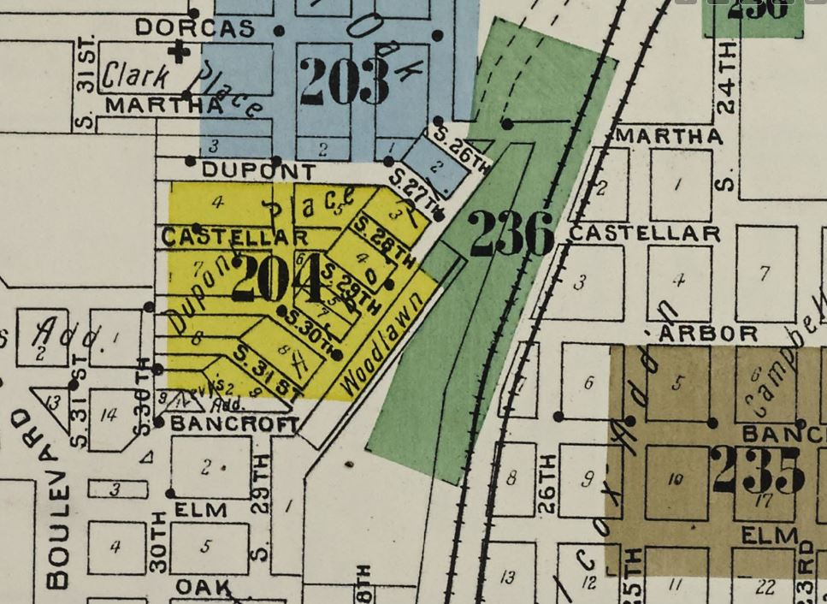
The best year-to-year information on the lives of the three brothers comes from the annual city directories. The Omaha city directories of the 1880s and 1890s show that each of the brothers moved and changed jobs frequently. Just like immigrants today, they were struggling to establish a place for themselves in the new land. In the mid 1880s the brothers usually lived by the Union Pacific Railroad Yards in Omaha. The neighborhood, which was part of Summit Addition, consisted of six one-block-long diagonal streets (S 26th to S 31st) just west of the railroad tracks between Martha (on the north) and Bancroft (on the south). The MERTES family of Charles’ future wife also lived in this neighborhood, on 30th Street, at the same time. This clipping showing the streets of the era was taken from a 1900 Sanborn Fire Insurance map of Omaha. The upper three little streets are still there today, wedged between the railroad and Interstate 480. The lower three streets were mostly removed to make way for the highway.

The Omaha
Meat Packing Industry

When Samuel arrived in 1878, the meat packing industry in Omaha was just beginning. Almost all livestock from the Midwest and upper plains was shipped to Chicago to be processed for sale in the rest of the country. But a handful of entrepreneurs saw that Omaha offered an advantage in that it was closer to the cattle and hogs being raised in the upper plains. That meant the live animals would spend one less day traveling by train to the slaughterhouse. That was one less day to feed them, one less day for them to lose weight due to travel, and one less day of freight costs. It was cheaper to ship processed meat than to ship live animals. And so in the late 1870s the first small packing houses began shipping processed meat east from Omaha.

One of the first three companies to do this was Harris & Fisher. This company started out as a small operation on Douglas Street by the river and then in 1878 built a larger facility next to the Union Pacific tracks in the Summit neighborhood in what was then the southern outskirts of the city. Omaha city directories show that all three REMER brothers worked there – Samuel in 1885, Charles in 1887 and 1888, and Michael in 1888. Also, Charles’ future wife Anna MERTES and her father John and brother Nicholas also worked there during the same period.

The book History of the State of Nebraska by A. T. Andreas, published in 1882, contains this description of the Harris & Fisher operation:

Harris & Fisher's Packing House.--Among the noteworthy packing establishments of Omaha, is the house of Harris & Fisher, which was completed in the latter part of 1878. It is located near the Union Pacific railroad track on the southwestern outskirts of the city. The packing house is a substantial brick structure, 32 x 100 feet, two stories high, with a basement. The killing department occupies the upper story, while the cutting is done in the lower story. The basement is used as a salting and curing room. The engine room is at the north end of the building. The hog and cattle run is on the east side, and is very conveniently arranged. The ice house, a frame building, is thirty feet wide by sixty feet long. On the west are two brick smoke houses. The entire cost of these buildings was $10,000.

The books History of the City of Omaha by James Woodruff (1894) and Omaha: The Gate City by Andrew Poppleton (1917) give more detail. The Harris & Fisher facility processed around four hundred cattle and four hundred hogs each day. Around fifty workers (mostly men) were employed at wages between $1.50 and $3.00 per day. This was before refrigeration existed so every winter the ice house was filled with blocks of ice taken from Carter Lake which was then used to keep the meat cool for processing in the summer. Because Chicago was closer to eastern markets, it wasn’t practical to ship meat on ice from Omaha. Most of Harris & Fisher’s products were salted, dried, cured, or canned.

Harris & Fisher may have been the largest processor of hogs and cattle in Omaha when the REMER brothers worked there in the mid-1880s, but it was still small compared to the packing plants in Chicago. And the owners of those plants had taken notice of what was happening in Omaha and of the potential that Omaha had. As large corporations often do, they decided to preempt the competition before it got very far by building their own large modern plants in Omaha. Swifts opened their plant at 27th & Q in 1887. Also building in Omaha at around the same time were Hammon, Omaha Packing, and Armour-Cudahy. Amour sold its share of the last one in 1890 and that plant became Cudahy. Armour returned and built its own plant several years later. During these boom years the population of South Omaha grew from 1,500 in 1886 to over eight thousand in 1890.

The Beef Skinners

Note: The University of Nebraska at Lincoln has a number of old newspapers online with indexes. The indexes were made with computer-generated text recognition, so they aren’t that accurate. But I’ve been able to find some interesting things by searching for the name REMER.

In the late 1800s, South Omaha was home to hundreds, if not thousands, of men skilled at killing, skinning, and butchering. And the three REMER brothers (Samuel, Charles, and Michael) were among the best. According to old newspaper articles, competitive beef-skinning was a popular spectator sport. People would pay to watch two men compete to see which one could kill and skin a cow the fastest and cleanest. The REMER brothers’ main opponents were a pair of brothers, Larry and Frank NOONAN.

The earliest reference to beef-skinning competitions that I’ve found was in the ‘In Omaha 30 Years Ago Today’ section of the 22 November 1918 Omaha Bee. The following line is reprinted from the newspaper’s 1888 issue: “Simon S. REMER, Anton Nokonov, and William Kalbe have returned from the Chicago slaughtering contest.”

In the 28 July 1890 Omaha Bee there’s an article titled ‘The Packing Employee’s Picnic’ about a picnic attended by over a thousand people in the town of Waterloo, just west of Omaha. The main attraction of the day was the cow-skinning contest. “In the beef skinning contest Larry NOONAN of the Armour-Cudahy packing house won first money, $80, $50 of which was offered by the South Omaha packers, to which Sheriff Boyd added $25 and J. W. Moore $5. Time 6 minutes, 7 seconds. George BAWST of Swift’s packing house took second money. Time 6 minutes, 47 seconds.” George BAUST (correct spelling) was Charles REMER’s brother-in-law. Charles’ wife Anna and George’s wife Teresa were sisters.

The 18 July 1894 Omaha Bee contained this notice: “At a picnic to be given at Sioux City, Larry NOONAN of South Omaha will compete with George STAPLETON of that place in a beef skinning contest for a purse of $250. Mr. NOONAN has beaten all records in this locality up to date and expects to win in Sioux City.” So as of 1894, Larry NOONAN was the regional champion.

The 16 July 1895 Omaha Bee provides the first evidence of a REMER participating in Omaha.

W. C. Keeline, Mr. Pokorny, Israel Frank of Omaha, and Gus Hendricks, who acted as judges for the beef killing contest at the butchers’ picnic Sunday, postponed their decision until yesterday. Mike REMER of Swift’s and Frank NOONAN of Cudahy’s were the contestants, and each had some claim to the first prize. REMER did his work in the better manner, swinging his knife with an ease and grace that would have done credit to a surgeon of twenty years’ experience and the judges decided that he scored the most points. But he finished the job in five minutes and twenty seconds, while NOONAN beat his fifteen seconds. NOONAN’s work, however, was marred by several technical defects which were apparent to the experts in the crowd. He failed to kill his beef at the first blow, as REMER did, and had to keep batting away until the animal finally caught the sledge hammer in the right spot and rolled over, a corpse. He did the skinning more rapidly than REMER, but there were several slashes in the hide which the judges decided ought not to have been there. It was decided that a compromise should be entered into, and the prize divided between the contestants.

Both men had completed the job in just over five minutes, about a minute less than Larry NOONAN had in 1890, but the article doesn’t say anything about a new champion. So by 1895 the record must have been around five minutes or less.

The ‘Magic City Gossip’ column of the 28 May 1897 Omaha Bee contains the line “Larry Noonan and Sam REMER are to engage in a beef skinning contest for a purse.” Unfortunately the new few issues don’t tell what happened.

The 03 July 1900 Omaha Bee has an article that shows that brother Charles also participated and that the times had gotten much better. “The beef skinning contest between Frank NOONAN and Charles REMER at the butchers’ picnic at Sarpy Mills Sunday resulted in a victory for NOONAN, who finished his bullock in 4 minutes and 44 seconds. REMER’s time was 4 minutes and 49 seconds.”

I found another article about the same contest in the 12 July 1900 issue of the German language newspaper Nebraska Staats Anzeiger, which my friend in Germany translated for me.

The Omaha butchers' picnic recently took place in Sarpy County. On this occasion, Karl REMER and Frank NOONAN competed in the beef skinning. Mr. Noonan was able to finish the skinning and dressing process in 4 minutes and 40 seconds, as well as Karl REMER, who did it in the same time. Both men's intention was to outmatch the champion beef dresser, Sam REMER, the well-known innkeeper of South Omaha, who skinned and dressed a beef according to all the rules of the art in 1897 in Council Bluffs in 4 minutes and 3 seconds. To this day, no butcher has succeeded in overtaking him. So this seasoned Bavarian is still the champion of the butchers and can be proud of this title.

So in 1897 (maybe at that contest with Larry NOONAN), Samuel REMER set a record of four minutes and three seconds and that record was still standing three years later. That 1900 article is the last reference to beef-skinning that I’ve found. So I don’t know if or when Samuel’s record was bested nor when the contests fell out of fashion. But there is no question that the three REMER brothers were among the best in Omaha.

PART THREE

Simon Samuel Remer (1860 – 1934)

Summary of Samuel’s Life

Samuel, the oldest brother, has the most interesting biography. He was the first to come to the USA, probably because of his age. But his life indicates someone who was always restless and looking for something different. Like his brothers, he started out working for small packing houses but by the late 1880s began working for himself. Between 1887 and 1901 (when he moved to Lawton, Oklahoma), Samuel at various times ran a meat market, saloons at three different locations, a transit house, and a hotel. Records are more infrequent after he left Omaha, but he ran a sausage shop in 1907 and a restaurant and bowling alley in 1909. After his wife, Augusta, died in 1910 he remarried twice and is known to have lived for a while in Wichita Falls and El Paso, Texas. There are some long gaps in his records so he may have lived some other places in the region, too. Samuel died in 1934 and is buried in Lawton, Oklahoma.

Details Of Samuel’s Life

Samuel Remer was the oldest of the three REMER brothers who immigrated to the United States. He usually appears in records as Samuel but is sometimes simply S. S. REMER. His first name of Simon is used on his tombstone and appears in a few other records, but mostly he was known as Samuel.

Census records indicate that Samuel was born in Germany in November 1860 and came to the USA in 1878. No record has been found of his arrival. A Samuel Remmer is listed in the 1879 Omaha city directory. He was boarding at South 15th and Williams and was employed as an ‘engineer’ for F. B. Kennard & Co., which was a large drug store at 244 Douglas. (The job title must have been a mistake. He is listed as a butcher living in a boarding house in the 1880 census.

On 31 December 1881, Samuel married Augusta (Gustinia) PROPLESCH in Douglas County (Book 8, page 461). Augusta was born in March 1862 and had immigrated from Germany in 1881 with her parents Christoff and Charlotte (REICH) PROPLESCH. (That is the correct spelling of PROPLESCH. I will keep alternate spellings when other records use them to make it easier for future researchers to find the same records.)

Samuel and Augusta had the following known children: Charles E. (February, 1883), Anna Charlotte (August 1885), Frederick William (April 1888), Lulu (June 1889), Frieda (April 1892), Samuel Thomas (October 1893), and finally a daughter named Barney born in 1900. The birth months are according to later census records because birth records haven’t been found for any of the children.

In the 1885 Nebraska state census, Samuel is listed as a butcher. Samuel begins appearing regularly in the Omaha city directories in 1885, when he is working as a butcher for the Harris & Fisher packing house and living on 26th Street by the UP track. In 1886 he lives at 2613 Walnut and is still working as a butcher. In 1887 he is running a meat market at 1410 South 13th Street (current site of the Prague Bar and Hotel).

In late 1887 or early 1888, Samuel became the first family member to move to South Omaha. In the 1888 directory he is living at 2613 N Street and running a saloon and restaurant nearby. The next year he has a saloon at a different nearby address but in 1890 no occupation is given.

The 22 November 1918 Omaha Bee, under the ‘In Omaha 30 Years Ago Today’ section, contains the item: “Simon S. REMER, Anton Nokonov, and William Kalbe have returned from the Chicago slaughtering contest.”

The 20 June 1889 ‘Notes About the City’ column in the Omaha Bee contains the one line item “S. S. Remer, Thursday, will go to Millard to select grounds for the shooting tourney July 4.”

Samuel is not listed in either the 1891 or 1892 directories (although his brothers are). Perhaps he briefly moved out of the area? In 1893 and 1894 Samuel runs a ‘transit house’ at 28th and M in South Omaha. He is missing again in 1895 and has no listed occupation in 1896. The 19 April 1894 ‘Magic City Gossip’ column in the Omaha Bee contains the single line “S. S. Remer is in from Springfield shaking hands with friends.” Springfield is a small town about fifteen miles southwest of Omaha. Maybe Samuel moved to this town for a short time and that would explain his absence in the 1895 directory. It may also be where he lived in 1891 and 1892.

In 1897 Samuel is running a boarding house at 214 North 25^{th.} (around N or O street). In1898 he has moved a block north and is the proprietor of Riley’s Hotel at 312 North 25th. In 1899, 1900, and 1901 he is listed as living at the Riley’s Hotel address but running a saloon at 2605 N. In the 22 October 1898 Omaha Bee (page 9), the Remer Hotel at 25th and O is listed as the polling place for the second ward, first precinct. That appears to be the 214 North 25th location. The 18 October 1900 also listed the Remer Hotel at 25th and O as a voter registration site.

The ‘Magic City Gossip’ column in the 28 May 1897 Omaha Bee contains the item “Larry Noonan and Sam REMER are to engage in a beef skinning contest for a purse.”

An article in the 29 January 1899 Omaha Bee tells of how Samuel caught a man who was writing bad checks. See the Addendum for the full text.

The ‘Magic City Gossip’ column in the 09 June 1899 Omaha Bee contains the item “The license committee of the council is considering Chief Carroll’s request to revoke the saloon license of Sam REMER.” The ‘Magic City Gossip’ column in the 29 June 1899 Omaha Bee: “Sam REMER, the N Street saloon keeper, has sued Police Captain Stephen Allie and his bondsmen for $5,000 for an alleged illegal arrest.”

In a list of items on fraternal organizations in the 22 April 1900 Omaha Bee (page 22), Simon S. REMER was elected ‘noble treasurer’ of the South Omaha lodge of the Independent Workmen of America.
The 1900 federal census has the family living at 312 North 25th Street in South Omaha. Samuel’s occupation was barkeeper and Augusta was running a boarding house. All the children are listed except Barney, who wasn’t born yet. Also living with the family were nieces and nephews Helena (born July, 1889), Samuel (born August, 1887), and Lena (born August, 1889) PROPLESH.

Samuel is listed in the Omaha city directory for the last time in 1901. Sometime that year the family moved to Lawton, Oklahoma. Daughter Anna Charlotte would marry in Lawton in December 1901. In April, 1902, Samuel’s eldest son, Charles E., was tragically killed in a gun accident in Comanche County, Oklahoma. It’s assumed that Samuel was in or near Lawton in the early 1900s because of Anna Charlotte’s marriage and Charles’ death. However, Samuel is not listed in either the 1903 or 1905 Lawton city directories.

The first definite record of Samuel in Lawton is the 1907 city directory when he is listed as a sausage manufacturer with his own shop. He is listed in both the regular residential section and under ‘Sausage Manufacturers’ in the business directory in back. He is not in the list of Comanche County tax payers, so must have been renting his house and place of business.

Samuel must have returned to Omaha for a visit in late 1908. The ‘Magic City Gossip’ column in the 21 November 1908 issue of the Omaha Bee contains the item “George Hoffman, Sam Remer, and Mike Remer went hunting last week and just returned with a killing of rabbits and a coon. A coon bake will be celebrated tonight.”

In the 1909 Lawton directory, Samuel is running a restaurant at 310 D Avenue and a bowling alley at 416 3rd Street. Once again he is not in the list of tax payers. The 1910 census has the family living at 310 D Street in Lawton and lists Samuel as a butcher and as a naturalized citizen. Living with Samuel and Augusta in 1910 are children Frederick W., Simon (Samuel) T., and daughter Barney, age 10. Also in the household are boarders August PROPLICH (56 and apparently a sibling of Augusta) and Margaret WINGBACK (19).

Samuel’s wife Augusta died in 1910 after the census was taken. She is buried in Highland Cemetery in Lawton. Samuel is not listed in the 1911 or 1913 Lawton city directories. Son Fred is the only REMER listed in 1911 and there are none in 1913. Samuel may have left the area for a few years after Augusta’s death. Son Samuel Thomas was living in Fort Smith, Arkansas at this time, so perhaps Samuel was there.

Ancestry does not have the 1915 Lawton city directory, but Sameul apparently returned to Lawton around that time. On 20 March 1915, Samuel remarried to Lillian NEUL, age 38, in Comanche County. Samuel is listed in the Lawton directory once again in 1917, with a wife named “Clara E”. He is working as a manager and living at 625 C.

Lillian/Clara must have died as on 27 February 1919, Samuel married a third time to Mattie HOUSTON, age 48, in Comanche County.
In March, 1920, Samuel and Mattie are listed in the federal census as S. S. RIMER and Mattie RIMER in Wichita County, Texas. Ages and other personal data match so it is clearly the same couple. That census shows that Mattie was born in Indiana. Looking back, in the 1910 census she is 38 and single, living with her mother Caroline in El Paso, Texas. Also in the household were her unmarried sisters Dessie (40) and Ora (33). Mattie was working as a grocery clerk while her sisters were telephone operators. It’s not clear what took her to Lawton, Oklahoma but she found a husband there late in life.

Samuel and Mattie are not listed in the Wichita Falls city directories of the era and after the 1920 census no record of them can be found until they are listed in the 1927 and 1928 El Paso city directories as living at 1111 Brown in El Paso, Texas. The couple is not listed in the 1929, 1930, or 1931 El Paso directories and also can’t be found anywhere in the 1930 census. In 1932 they are in the El Paso directory living at 1012 Wyoming Street. This edition includes occupations and Samuel is listed as a meat cutter. The couple is not in the 1933 and 1934 El Paso directories.

Samuel died in 1934 and is buried in Highland Cemetery in Lawton. Mattie is listed as living with a boarder in Lawton in the 1940 census. She must have died soon afterwards as she is buried in Highland Cemetery and the tombstone gives the dates of 1872-1940.

According to Charles Richard MOORE, his mother Helen and her parents Charles and Anna REMER traveled by train from Omaha to Oklahoma to visit Samuel sometime in the 1920s.

Samuel and Augusta’s Children and Grandchildren

Charles E REMER -– (son of Samuel)

Charles was born in February 1883 in Omaha. In the 1899, 1900, and 1901 Omaha city directories Charles is listed as living with his parents. In 1899 his occupation was clerk, in 1900 he was a bartender at his father’s bar, and in 1901 his occupation was listed as manager. He was killed in a gun accident outside Lawton on 1 April 1902. He is buried in Highland Cemetery. (An article about his death in in the Addendum section.)

Anna Charlotte REMER – (daughter of Samuel)

Her full name was Anna Charlotte REMER but she was sometimes listed as Lottie.

Anna Charlotte REMER married Anthony F. POKORNY on 7 December 1901 in Comanche County, Oklahoma. (The POKORNY family has also moved to Lawton from Omaha.) The couple are listed in Lawton in the 1910 census with a 3-month old son named Edward. Anthony was employed as a mailman and was also from Nebraska.

The couple apparently returned to the Omaha area at least briefly in early 1910. In 1942 a ‘Delayed Certificate of Birth’ for Edward’s 6 January 1910 birth was filed in Council Bluffs and Edward’s burial record lists his place of birth as Council Bluffs, Iowa. His place of birth is listed as Nebraska in the 1910 and 1920 census and as Iowa in 1930 and 1940.

In the 1911 and 1913 Lawton directories the couple is listed as living at 110 A Avenue. In 1917 they had moved to 815 E Avenue. Anthony is consistently listed as a letter carrier. The Anthony POKORNY family continued to live in Lawton and Anthony continued to work as a mail carrier. In the 1920 census Lottie’s name is given as Charlotte Hannah. In addition to Edward there is now a 4 ½ year-old daughter, Natalie, born in Texas.

In the 1930 census twenty-year-old son Edward is an electrician for Bell Telephone. Besides fourteen-year-old Natalie, the household includes Anthony’s 86-year-old father Antone POKORNY (born in Austria) and 38-year-old cousin Caroline PROPLESH from Nebraska. The 1940 census lists Anthony and Charlo , 24-year-old Natalie, one-year-old grandson Anthony (apparently Natalie’s child), and cousin Caroline PROPLESH.

Lottie died on 26 April 1970 and is buried in Highland Cemetery in Lawton. Her tombstone gives her date of birth as 13 August 1885. Her husband, Anthony F. POKORNY (28 October 1877 to 15 February 1962), is also buried there, as is cousin Caroline (1890-1947).

Grandchild: Natalie POKORNY – (daughter of Anna Charlotte, granddaughter of Samuel)

Natalie was born about 1915, probably in Lawton. On 2 May 1937, a marriage license for Natalie and Philip W. RUSSELL was issued in Lawton. The wedding apparently never took place. In the 1940 census Natalie, surname unchanged, is living with her parents. Philip is also living with his parents. Sometime around 1938 or 1939 she gave birth to an out-of-wedlock son, Anthony, who is listed with her and her parents in the 1940 census.No further records of either Natalie or Anthony have been found.

Grandchild: Edward POKORNY – (son of Anna Charlotte, grandson of Samuel)

As noted under his mother’s details, Edward was apparently born in Council Bluffs, Iowa on 6 January 1910.

In mid or late 1930 (after the census was taken), Edward married Arita Willadean LASHBROOK (born 1 January 1911 in Lawton). In the 1940 census Edward is working as a station installer for Bell Telephone and living in Ada, Pontotoc County, Oklahoma. The family consists of Edward, wife Arita, daughter Edrita, and son Arthur.

Edward died 14 November 1990 in Ada. His wife Arita died 25 August 1999. They are buried in Rosedale Cemetery in Ada.

Edward and Arita’s first child was daughter Edrita, born 29 October 1931 in Shawnee, OK. She later married Dr. Thomas Clark ODEN. She died 25 January 1998 in Oklahoma City and is buried in Rose Hill Burial Park in that city. Husband Thomas died 8 December 2016 and is buried next to her. They had one known child, Thomas ODEN Jr,, born 21 December 1956 in Connecticut and died 21 August 2016 in Oklahoma City.

Edward and Arita’s second child was Arthur Edward POKORNY, born 2 December 1935 in Oklahoma and died 7 September 1972 in Edmond, OK. He is buried in Gracelawn Cemetery in that city. He was a doctor, but it’s not known if the degree was medical or academic. He is not known to have married.

Edward and Arita’s third child was Charles Anthony POKORNY, born 20 December 1940 in Ada. He married Lou Ann PYBAS (born 27 May 1941) on 15 November 1963. The couple had two children, Debra and Brenda. He died 6 September 2008 in Tulsa and is buried in Rosedale Cemetery there.

Frederick William REMER – (son of Samuel)

Frederick was born in Omaha on 20 April 1888 and moved to Lawton, Oklahoma with his family shortly after 1900.

He is listed as a ‘draughtsman’ in the 1907 Lawton city directory. In 1909 he is the manager of his father’s restaurant. He is double-listed in the 1910 census as both living with his family and living at the fire station, where he is an assistant fireman. In the 1911 Lawton city directory he is listed under the name Frederick REAMER, a ‘nozzleman’ for the fire department and boarding at the Lawton Hotel. He is the only Remer listed that year.

In 1913 Frederick and his wife Minnie are listed in the Lawton city directory. He is still employed as a fireman. He is not in the 1915 Lawton city directory. On 5 June 1917, Frederick registered for the World War I draft in Sebastian County, Arkansas. In the 1920 census Frederick is living in Fort Smith, Arkansas with his wife Minnie (25) and daughter Francis (6). His occupation is listed as a machine operator.

That census record was collected on 2 January 1920. (That was the only time the census was collected so early.) Frederick died shortly after that as in the Highland Cemetery in Lawton there is a tombstone for Frederick William REMER with a death date of 14 February 1920. Below his name the inscription reads “Arkansas - PVT 152 INF – 39 DIV” which, I believe, means he was a veteran of 39th Division (which research confirms came from Arkansas). Given that he was only thirty-two, the most likely cause of death in 1920 would have been the Spanish Flu epidemic. On 4 September 1920, Minnie remarried to Arthur G. WHITE in Forth Smith.

Arkansas did not issue birth certificates until 1914. In 1943 Frederick’s daughter Francis Lula Mae REMER received a delayed birth certificate. It gives her date of birth at 6 August 1913 and lists the parents as Frederic William REMER (age 24 and born in Omaha, Nebraska) and Minnie Lee GILPATRICK (age 18 and born in Thackerville, Indian Territory – later Oklahoma). According to this document, at the time of her birth they were living outside Fort Smith, Arkansas, in the small town of Barling. The affidavit was signed by Francis’ grandmother, Mary Jane GILPATRICK, age 72, of 808 South 5th Street in Lawton, OK. No additional information about Francis has been found.

Lulu REMER – (daughter of Samuel)

Lulu is listed with the family in the 1900 census. She is listed as an employee of her father’s sausage shop in the 1907 Lawton city directory and as a waitress at her father’s restaurant in 1909. She is not living at home in 1910. She would have been twenty-two and must have already married but no record has been found of either her marriage or her death.

Frieda REMER – (daughter of Samuel)

Frieda is listed living with her parents in the 1907 Lawton City Directory. In 1909 she is working as a waitress in the family restaurant. Frieda married Paul W. RAMSEY on 18 December 1909 in Lawton. The 1910 census has the couple living as boarders in the household of Charles Anderson in Lawton. Paul is 22 years old, a plumber, and from Alabama. Nothing more has been found of the couple. They are not in the 1911, 1913, or 1917 city directories nor can they be found in any later nationwide census index.

Samuel Thomas REMER - (Son of Samuel)

Samuel Thomas was born 9 October 1892 in Omaha and moved to Oklahoma with his family. He is living with his parents in the 1910 census.

Soon after the 1910 census Samuel married Donna Callie GILPATRICK (born in Kentucky 17 June 1892). They lived for a while in Sebastian County, Arkansas as their first two children, the twins Mary Nathalee and Charlotte Gennalee were born there on 26 July 1912, as was son Samuel Eugene in 1915.

After the birth of Samuel Eugene the family moved just across the border to Spiro, Le Flore County, in northeast Oklahoma as that is where Samuel Thomas was living when he filled out his World War I draft registration. There is no record that he served. In the 1920 census Samuel Thomas is listed in Spiro with wife Donna, the twins, and sons Samuel Eugene and newborn Frederick. He was working as a farmer. Another son, Edward Alfred, was born in 1921.

Sometime in the early 1920s Samuel Thomas moves his family back to the Lawton area as son Elmer Robert was born in 1925 in Medicine Park, just north of Lawton.

The 1930 census has the family living in Lake Township, Comanche County. Samuel is employed as a stone mason. The household includes the couple; children Gennalee and Nathalee (18), Samuel E (15), Freddie (11), Eddie (9), and Elmer (5); and Samuel PROPLESH, a cousin born in Nebraska.

The family stayed in Comanche County until at least 1935, but in 1940 are back in Spiro. Still at home are children Edward A (19), Robert S (15), William T (9), John R. (6), and Betty J (3). Samuel PROPLESH is still living with them. Samuel Thomas REMER now lists his occupation as farmer.

Samuel Thomas died 18 August 1952 in Fort Smith, Arkansas and is buried in Spiro. His wife Donna died 20 August 1959 and is also buried in Spiro.

Grandchild: Mary Nathalee REMER – (daughter of Samuel Thomas, granddaughter of Samuel)

Mary Nathalee was born in Sebastian County, Arkansas on 26 July 1912 with her twin sister Charlotte. She died in Fresno, California on 1 November 1986. Her surname at the time of her death was COLEMAN. Nothing more about her has been found.

Grandchild: Charlotte Gennalee REMER – (daughter of Samuel Thomas, granddaughter of Samuel)

Charlotte Gennalee was born in Sebastian County, Arkansas on 26 July 1912 with her twin sister Mary Nathalee. She married Edmond R. KINSER (18 March 1913 – 25 April 1969) of Lawton. At some point they moved to California as they are living in Merced, CA in 1960 and in nearby Atwater in 1967. It isn’t known if they had children. Charlotte died 31 July 1985. She and her husband are buried in Merced.

Grandchild: Samuel Eugene REMER – (son of Samuel Thomas, grandson of Samuel)

Samuel Eugene’s age is given as five in the 1920 census and as fifteen in the 1930 census, indicating he was born in 1914 or 1915, but his tombstone lists 1913. In 1935, Samuel Eugene was killed in a dynamite blasting accident while working on a road in Medicine Park, near Lawton.

Grandchild: Frederick J. REMER – (son of Samuel Thomas, grandson of Samuel)

Frederick J was born 22 April 1919 in Oklahoma On 18 December 1939 he married Helen GISSENDAMER in Comanche County, OK. Helen was born 14 March 1919 in Sterling, OK. Helen died on 6 November 1955 in Chickasha, Grady County, OK. The couple had one son, Leon REMER. He was born 24 February 1941 in Spiro, died 20 August 2016 in Keota, OK. See the Addendum section for his obituary. Frederick later remarried as his double tombstone also had space for Macklean REMER (born 25 August 1934, no death yet noted). Frederick died 26 April 1996 in Spiro, Le Flore County.

Grandchild: Edward Anthony REMER – (son of Samuel Thomas, grandson of Samuel)

Edward was born 26 December 1920. He died 2 August 1985 in Spiro. He married Virginia Jo STATHAM (1925-2014). Son Clarence REMER was born 11 September 1933. He is buried as Pfc Clarence REMER, died 29 September 1951 in Sallisaw, Oklahoma cemetery. He likely died in the Korean War. At the time of Virginia’s death the couple had four surviving children: Eady Joann REMER of Tulsa; Sharron Kaye HIATT of Kirksville, MO; Nan OLIVE of Poteau, OK; and Samuel T. REMER of Vancouver, Canada.

Grandchild: Elmer Robert REMER – (son of Samuel Thomas, grandson of Samuel)

Elmer Robert was born 3 February 1925 in Medicine Park, Comanche County, OK. He normally went by the name Bob. He is sometimes listed as Robert Elmer. Bob served in the US Navy in World War II. He later owned a meat processing plant in Sallisaw (near Spiro).

On 25 December 1989, Bob was shot and killed by his son-in-law, Gary Wayne CLOUD. Bob’s wife Jane was also wounded in the attack. Bob is buried in Spiro. See the Addendum for an article about his murder and the conviction.

His wife Virginia later remarried and passed away in 2014. See the Addendum for her obituary. Virginia’s obituary lists the following children (as of 2014): Eady Joann REMER of Tulsa; Sarron Kaye HIATT (husband George) of Kirksville, Missouri; Kerry Nan OLIVE of Poteau, OK; and the couple’s only son Samuel T. REMER of Vancouver, Canada.

Grandchild: William (Bill) Thomas – (son of Samuel Thomas, grandson of Samuel)

William Thomas was born 9 July 1930 in Oklahoma. He died 12 October 1984 in Spiro and is buried in Spiro Cemetery. Nothing else about him can be found, including whether or not he had a family.

Grandchild: John Ray REMER – (son of Samuel Thomas, grandson of Samuel)

Johnnie, as he was known, was born 12 November 1933. In 1955 was attending Oklahoma State University. As Dr. Johnnie Ray REMER, in 1981 he donated some money to the College of Veterinary Medicine at Oklahoma State. He died 30 March 1993 and is buried in Spiro next to his wife Gayle Vaught REMER.

Grandchild: Betty J REMER – (daughter of Samuel Thomas, granddaughter of Samuel)

Betty J is listed as a three-year-old daughter of Samuel Thomas in the 1940 census. Betty REMER graduated from Spiro High School in 1954. Nothing else has been found about Betty.

Barney REMER – (daughter of Samuel)

The 1910 census lists Samuel and Gustina REMER as having a ten-year-old daughter, born in Nebraska, with the unlikely name of Barney. Nothing more has been found about her or any other possible youngest daughter.

Other Oklahoma REMERs

Records of two other REMER graves in Oklahoma have been found. These are probably connected to the Samuel REMER line. Tilda Alene REMER, 22 October 1932 to 26 September 1999, is buried in Spiro Cemetery. She could be the wife of William Thomas REMER. Or perhaps she has another connection to the family. Spiro Cemetery has the grave of Robert Thomas REMER, 29 June 1949 to 16 Sept 1986. He was veteran and fought in Vietnam 1966 to 1968. He is likely (but not confirmed) the son of Bob REMER.

Marriage License for Simon Samuel REMER
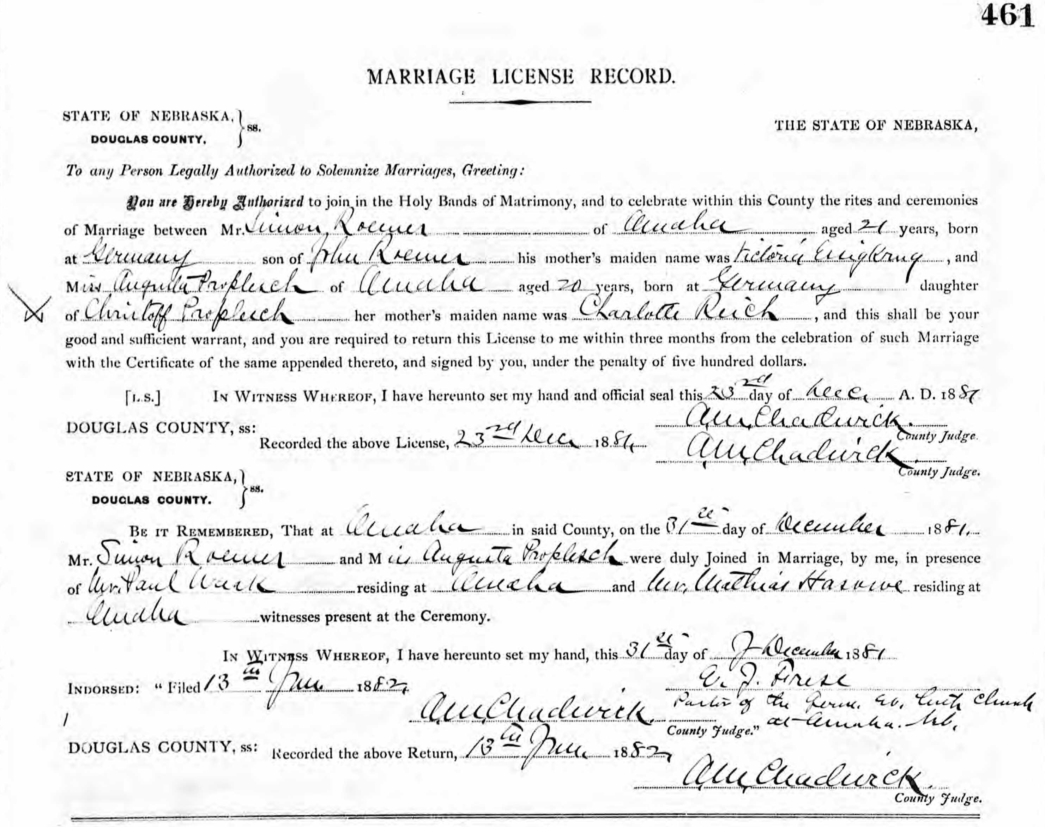
PART FOUR

Charles Remer (1864-1943)

Charles was born 15 September 1864 in Bavaria. His name in German was Karl but he apparently anglicized it as soon as he arrived. The only time I’ve found the name ‘Karl’ used for him was in the article on beef-skinning in the Omaha German language newspaper. It’s not known what his full name was or if Charles was his first or last name. In one of the Omaha city directories he is listed as “Christ” Remer, so maybe his other name was Christian.

Charles came to USA in 1881 per census records. The series Germans to America lists a Carl Remmler, age 17, laborer, arriving in New York from Hamburg on the Vandalia alone (i.e. without other family) on 1 August 1881. The listing says he was from Wurttemberg. This could be him as we know that he arrived alone in New York. But the family was from Bavaria, not Wurttemberg, which is just west of Bavaria.

Charles first shows up in the Omaha city directories in 1884. He is working as a butcher at Oberne, Hosick & Co at 1415 Harney and boarding at “U P Ry nr Summit” which I read as the UP rail yard near the Summit Addition. In 1885 his is working as butcher at J M Yerga’s meat market at 1107 Farnam and boarding at South 29th north of the UP track. (That could be the same place as 1884.) His future wife and the MERTES family are living at South 30th near the UP track at the same time. In 1886 Charles is working at Fred Hickstein’s meat market at 616 South 9th and boarding at the same address. In 1887 and 1888 he is working at the Harris & Fisher packing house.

Charles married Anna MERTES on 27 April 1887 at Mary Magdalene Church in South Omaha. For details of her family see the accompanying documentation on the MERTES family.
Charles became a US citizen in 1887.

In the 1889 Omaha city directory, Charles is running a saloon at Bellevue and A in South Omaha. (Bellevue was the old name for present-day 24th Street.) Unlike his older brother, Charles apparently didn’t care for tending bar. From 1890 onward his occupation is always listed as something connected to butchering and the packing houses. Between 1890 and 1910 he changed employers a lot but most of the time was working for one of three big packing houses – Cudahy, Omaha Packing, or Swifts.

The family was missed in the 1900 census. They were living at 1318 Z Street at the time and the census records show that the census taker started at 1321 Z Street.

An article on South Omaha city government in the 17 April 1906 issue of the Omaha Bee includes the item that Charles REMER was appointed Stock Inspector for a term of office to begin on May 1. He apparently lost this job in June 1908 after the election of a new mayor. In the South Omaha city news in the 19 October 1906 issue of the Omaha Bee: “Charles REMER, live stock inspector for the city, reported that he had condemned twenty-three head of cattle, twelve head of hogs, twenty-nine head of sheep, and seven head of horses during the past month.”

The 1910 census has the family at 1318 Z Street. The household included Charles and Anna, all five children, and Anna’s widowed father John MERTES. After 1910 Charles appears to have stuck to working at Cudahy. Beginning in 1914 he is usually listed as either a foreman or an assistant foreman.

In the 13 April 1912 Omaha Bee, Charles is listed as a one of two Democratic judges for the first precinct of the third ward.

In the 1920 census all the children are still at home except for Anna, who has married. John MERTES had died a few years before. In the 1930 census all three sons are still living at home. Helen had married the previous year and moved out.

Charles died in December 1943 in Omaha. His wife Anna MERTES REMER died in Omaha in November 1947.

Charles and Anna’s Children and Grandchildren

Karl Claude REMER – (son of Charles)
Karl Claude was born on 14 May 1889 and died the next day.

John REMER – (son of Charles)
John was born 7 February 1891. Died 23 October 1891

Edward Leon REMER – (son of Charles)

Edward was born 10 March 1893 in South Omaha. Omaha city directories show him working as butcher at the Omaha Packing Company in 1910, as a ‘carp’ (carpenter?) at Swifts in 1914, and a motorman in 1916.

Edward’s World War I draft card has him 24 years old and working as an electrician’s helper for Cudahy. He enlisted on 15 June 1918 and was released from service on 18 January 1919.

The 15 June 1918 Omaha Bee has him in a list of men being sent to Lincoln for a ten-week course in “special mechanical or radio work”.

In June 1938 Edward married Anne SKIFFINGTON. Anne was born 13 June 1887 in Mount Carmel PA. Her parents were Peter and Emma BRENNAN SKIFFINGTON. The surname is sometimes spelled with a ‘v’ instead of ‘ff’.

When Edward filled out his World War Two draft card he was 49 years old and living at 1415 Jefferson Street in Omaha. City directories in the 1940s list Edward as working as a wire-man or electrician at Cudahy.

Sometime after World War II Edward and Anne moved to Tucson, Arizona. Anne died 4 November 1963 in Tucson, Arizona. Edward died 1 January 1981 in Tucson, Arizona. He is buried at Golden Gate National Cemetery in San Bruno, CA. Section Z, Site 730. Anne is buried next to him.

William Robert (Bill) REMER (son of Charles)

William was born 28 February 1897 in South Omaha.

City directories list him as a laborer (1914) and as a clerk for the CB&Q Railroad (1916). During the 1920s and 1930s we often worked at the Remer Brothers Garage.

In the 1935 Omaha directory Bill is living at 1318 Z w/ parents. In 1948 he was an employee at the Dr. Pepper Bottling plant. In 1949 he was a bottler at the Falstaff Brewery. He also worked for Falstaff in 1951 and 1954.

Bill never married. He lived with his parents all his life and then inherited the family house on Z Street when his mother died. So he lived in the same house all his life. According to family stories, Bill drank a lot and wasn’t very friendly.

Bill died in 1968 and is buried in Mary Magdalene Cemetery in Omaha.

Anna Christine REMER (daughter of Charles)

Anna was born 2 July 1901 in South Omaha. She married Otto Robert PRILL on 14 August 1919 in Omaha. Otto was born 28 November 1888 in Charter Oak, Iowa.

The 1920 Census lists the couple as living with Otto’s parents (Fred and Augusta) on 5343 North 27th Avenue. The 1930 census lists Otto (42), Anna (28), Edward (9), Mary A (8), Bernard (6), and Richard (6 months). Otto is a cook. The family lives at 1334 Z Street, near Anna’s parents.
Sometime in the early 1940s the family moved to California. Otto died 27 June 1943 in San Bruno, San Mateo County, California.

Around 1946 Anna remarried James E. FLANNERY (19 Feb 1897 to 15 December 1956).
Anna died 19 November 1991 in San Jose, CA.

Grandchild: Edward Otto PRILL - (son of Anna, grandson of Charles)

Edward Otto was born 20 June 1920 in Omaha He married Beverly June Bell in Papillion, Nebraska 18 July 1939. He served in US Army 317th Troop Carrier Squadron from 20 July 1944 until 11 March 1946 as PFC. In 1960 he resided at Petaluma, Sonoma County, CA. Edward died 25 October 1969 in Springdale, Washington County, Arkansas. He is buried in Mary Magdalene Cemetery in Omaha. At the time of his death his children were listed as Gayle RASMUSSEN, Joyce MOLLER, David PRILL, and Ed PRILL. His wife Beverly was born 20 June 1923 in Omaha. She died 21 December 1988 in Santa Rosa, CA. She did not remarry

Grandchild: Mary Anne PRILL - (daughter of Anna, granddaughter of Charles)

Mary Ann was born 21 December 1921 in Omaha. She married Andrew Henry SUCCETTI (6 February 1913 to 2 August 2005) on 10 November 1966 in Carson City, Nevada. It’s not known if they had children. She died 24 September 2003 in San Jose, CA

Grandchild: Bernard Arthur PRILL - (son of Anna, grandson of Charles)

Bernard (Bernie) was born 1 December 1923 in Omaha. He served in US Army from 5 February 1943 until 12 December 1945. H married Libby Stranik on 9 November 1946 in Papillion. They had one daughter named Colleen. She married and had one son. Bernie died 18 October 1984 in Omaha. His wife Libby was born 25 June 1919 in Leigh, NE and died February 1993 in Nebraska.

Grandchild: Richard (Dick) Carl PRILL - (son of Anna, grandson of Charles)

Dick was born 30 September 1929 in Omaha. He married Bernice Katherine SCHNAUBELT on 9 November 1951 in Stockton, CA. They had six children, including Richard Carl Prill Jr.
Living children at time of his death were Mary HUTCHENSON, Christine BERRY, Anna COLSON, Richard PRILL and Patrick PRILL. (Son Richard C Prill Jr married Sharon L BROWN in Reno, 12 February 1983.)
Dick lived in Fort Bragg from at least 1982 to 2009 and died on 24 December 2009 in either Fort Bragg or Uikiah. His wife Bernice was still living at the time of his death.

Grandchild: Virginia Josephine PRILL - (daughter of Anna, granddaughter of Charles)

Virginia was born 24 May 1931 in Omaha. She married on 4 April 1951 to George Stephen SUTTON (1920-1998). Their children were Linda Rae SUTTON (1948-1992); Violet Jo SUTTON (1952-2005) and George S SUTTON Jr. The family lived in Santa Clara and San Jose CA. Virginia died 4 January 1979 in Santa Clara, CA

Carl Francis REMER (son of Charles)

Carl Frances was born on 28 September 1903 in Omaha. He was still single and living at home in 1930. From about 1925 until about 1947 he was operated the Remer Brothers Garage on the corner of 13th and Z. In the 1940 census he is listed with his wife Helen at 4520 ½ South 19th Street. They had no children. After selling the garage Carl took various jobs. In the 1949 city directory he was a mechanic for Sam J. Breci and lived at 1324 Deer Park Blvd. In 1951 he was a bartender at Sonny’s Liquours and still living at Deer Park Blvd. In 1954 he was listed as a shipping clerk. His wife preceded him in death by several years. He spent the last years of his life living with Libby and Colleen PRILL, widow and daughter of his cousin Bernie PRILL. He died in December 1989. His obituary appeared in the January 1 1990 Omaha World Herald.

Helen Elizabeth REMER (daughter of Charles)

Helen was born 6 October 1907 in South Omaha. For details of her descendents see the section for her husband Charles Franklin MOORE in document on the MOORE family.

The Remer Brothers Garage

The Remer Brothers Garage was primarily operated by Carl Remer, who was a trained mechanic, but brothers Edward and Bill worked there occasionally. Maybe all three owned the garage initially but eventually it was the sole property of Carl. The annual Omaha city directories give an idea of who was working there each year. The garage first appears in the directories in 1925 so opened around that time. The three brothers also had a filling station at Railroad and Harrison in 1925. Apparently they soon sold that as it was not listed in subsequent years. Carl sold the garage around 1947.

1925 – All three brothers. The also had a filling station at Railroad & Harrison.
1926 – All three brothers.
1928 – Ed & Carl
1929 – All three brothers
1931, 1932, 1934 1935 1936 – Owned & operated by Carl & Edward;
1940 – Listed as William, Carl, & Edward
1941 – Only Carl. Edward is now at Cudahy and no occupation listed for William
1942 – Carl is owner. William is listed as a mechanic.
1945 – Carl is owner. William not listed at all.
1946 -– Carl is owner. William is listed as a mechanic.
1948 – Garage is not listed. No occupation given for Carl. William elsewhere.

Marriage License of Charles REMER and Mary Anne MERTES

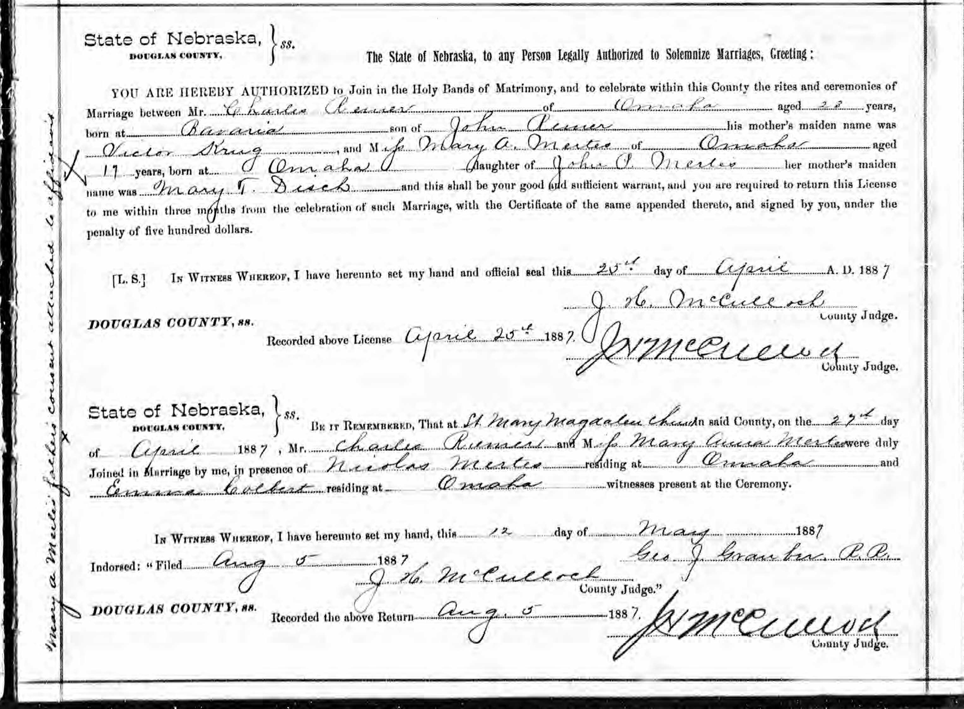

PART FIVE

Michael Remer (1867-1934)

Michael, the youngest REMER brother, was born about 1867 in Germany. No record of his arrival in the USA has been found, but the 1910 census says he immigrated in 1885 and his is listed in the 1885 Nebraska state census as a boarder with William and Charlotta Schamber, next door neighbors to his brother Samuel REMER.

Douglas County marriage records (Book 14, page 111) show that on 2 February 1890 Michael married Bertha OHLENDORF. Brother Charles served as a witness. Bertha was also born in Germany and was the daughter of August and Gustina OHLENDORF. The handwriting on the marriage license is difficult to read but Gustina’s maiden name appears to be TREVINS or TREMMS or something similar. According to the 1900 census, August and Gustina were married in 1874 and came to the USA in 1882.

Michael is first listed in the Omaha city directory in 1888, as a butcher working for Harris & Fisher. From 1889 to 1894 (excluding 1890 when he is not listed), the directory lists Michael as a laborer at the Swift’s Packing House. Michael is not listed in 1895 and has no employer listed in 1896 and 1897. There was a large unsuccessful strike in the packing plants in 1894. Maybe Michael was among the many workers who were not given their jobs back after the strike failed.
For the years 1898, 1899, and 1900 Michael is a foreman at the Omaha Packing Company.
Michael hasn’t been found in the 1900 federal census.

In December 1901, Michael got in trouble with the law over his taking $400 that had been forwarded to him for cashing pay checks at his bar. See Addendum Three.

In subsequent years between 1901 to 1916 Michael is variously listed as a laborer or a butcher. In 1907 and 1911 his employer is given as Cudahy, but otherwise it isn’t listed. His family lived at at least four different addresses in South Omaha during this period. He is not listed in 1905 and 1906 (and Ancestry doesn’t have directories for 1903 and 1904). I wonder if he may have joined Samuel in Oklahoma for a while.

The ‘Magic City Gossip’ column in the 21 November 1908 issue of the Omaha Bee contains the item “George Hoffman, Sam Remer, and Mike Remer went hunting last week and just returned with a killing of rabbits and a coon. A coon bake will be celebrated tonight.” Apparently brother Samuel had returned for a visit.

In the 1910 census Michael’s family is renting a house at 294 South 24th Street. His occupation was listed as butcher and he was not yet a citizen. Beside Michael and Bertha, the household included daughter Helen (19) and sons Henry (18), Walter (16), “Lorence” (13), and Carl (9).

Sometime soon after the 1916 directory came out, Michael moved his family to South St. Paul in Dakota County, Minnesota. He and sons Walter, Lawrence, and Carl are listed at 115 South Concord Street in the 1917 St. Paul city directory. (Married women were not listed unless widows.) Eldest son George stayed in Omaha. The 1920 census lists Michael and Bertha at the South Concord Street address. Michael is the “prop” (proprietor?) of a “Serum Plant” and is now a naturalized citizen. Daughter Helen (29) and son Carl (18) are still living with their parents.

In the 1928 and 1929 city directories, Michael is working as a driver for his sons’ transportation company. In the 1930 directory he is a yardman for the Minnesota Pig & Cattle Company. In the 1930 census Michael and Bertha are at the same address. Also in the household are son Carl (29) and granddaughter Phyllis (6). Carl is a truck driver for a furniture company and Phyllis is Carl’s daughter from an unknown marriage.

Michael died on 6 August 1934 in Dakota County, Minnesota. In the 1940 census, Bertha (74) is living with her son-in-law Walter WORM (43), a casket saleman. He is the widower of daughter Helen. Also in the household is Phyllis (16), listed as Walter’s niece. Bertha is probably the Bertha REMER listed as dying in Ramsey County (St. Paul), Minnesota on 17 July 1946.

Michael and Bertha’s Children and Grandchildren

Helen REMER - (daughter of Michael)

Helen was born in Omaha about 1891. Omaha city directories show her working as a waitress in 1910, a clerk in 1914, and a clerk at Thompson, Belden, & CO in 1916. She lived with her parents until at least 1930. During the 1930s she married William WORM. She died in 1939. Apparently the couple had no children as none are listed with William in the 1940 census. William remarried in 1941.

Henry George REMER - (son of Michael)

Usually he is listed as Henry or Henry G, except in 1920 when he is George H. According to the Social Security death index, Henry was born 29 January 1892.

Henry married Mary KRAMOLISCH, age 20, in Omaha in October, 1912. They are listed under marriage licenses granted on the front page of the 6 October 1912 Omaha Bee.

Henry stayed in Omaha and did not move to Minnesota with the rest of his family. In the 1918 Omaha City Directory he is working as a yardman at Tagg Brothers and Moorhead. His family lived at 5107 South 18th Street.

In the 1920 census he is listed as George H REMER with wife Mary A. at the South 18th Street address. Living with the couple and two sons is Mary’s brother Dewey KRAMOLISCH (21). In the 1929 city directory the family is still on South 18th Street. Henry is working as a yardman at Lee L S Com Co.

The 1930 census lists Henry (38), Mary (37), and sons George H. (16) and Leonard (14). The 1935 Omaha city directory has Henry working for the Lee company. Son Leonard is living at the same address.

In the 1940 census the family is still at 5107 South 18th Street. Living with Henry and Mary are son Leonard (25), daughter-in-law Helen (25), and grand-children George (4) and Robert (10 months). (Helen and the children appear to have been son George’s family.) Henry is a salesman for the Leon Stock Company.

The 1951 Omaha Directory lists Henry and Mary at the same address. He is a salesman for the Lee Live Stock Comm Co. Living in the same house is son Leonard (a foreman at Sterling Mfg) and wife Viola. (A different name for Helen or a different wife?) According to the Social Security death index, Henry died in 1973. His last residence was at zip code 68107 in Omaha.

Grandchild: George H. REMER - (son of Henry, grandson of Michael)

According to census records, George H. was born about 1913. The 1935 and 1936 Omaha City directories list George REMER and wife Helen living at 5416 South 24th in 1935 and 1936 city directories. In 1936 is working as a clerk at the Farmcrest Dairy Store.

George can’t be found in the 1940 census. The Helen REMER and children living with father Henry in the 1940 census must be George’s family as city directories of the time period don’t list a spouse for Leonard.

The Social Security Death Index lists a George REMER born in Nebraska 3 August 1913 and died September 1967. The birth date matches George’s age in the 1920 and 1930 census. No other records can be found for George, Helen, or the sons George and Robert.

Grandchild: Leonard Carl REMER - (son of Henry, grandson of Michael)

The Social Security Death Index lists a birth date of 1 July 1915 which fits for the age listed in the 1930 census.

The 1936 city directory lists Leonard as a student living at home. The 1940, 1941, and 1942 directories show him as single (no spouse name is given), so there is no reason to believe that the Helen and children living with him and his parents in the 1940 census are his family. They must have belonged to his older brother. The 1942 city directory gives his occupation as accountant.

Leonard’s World War II draft registration (presumably filled out late 1941 or early 1942) says he was born 1 July 1915 in Omaha. His mother is listed as next-of-kin (not a wife). He is working for Northern Natural Gas. Although Leonard filled out a draft card, there is no record that he served. City directories weren’t published for 1943 and 1944, so it’s not known if he was in Omaha. He was not listed in the 1945 directory, however.

On 16 June 1945, Leonard Carl REMER married Betty Marguerite CASEY in Tacoma, WA. Leonard was 29 and born in Nebraska. Betty was 25 and born in Montana.

The 1946, 1948, and 1949 directories list Leonard as living at 1711 P Street in Omaha. In 1946 and 1948 his wife’s name is given as Pearl but in 1949 it’s Betty (so Pearl was likely a nickname). In 1946 Leonard is working as a welder at Gate City Iron Works. In 1948 he is an inspector at Sterling Mfg. In 1949 he is an agent for Washington National Insurance.

On 10 February 1950 in Yankton, South Dakota, Leonard married Viola BIERLE, age 35 and also of Omaha. It’s not known whether Betty died or if the couple divorced. Leonard and wife Viola are listed living at 2621 E Street in Omaha in the 1954 city directory. He is an agent for the L J. Marcotte Insurance Company.

The Social Security Death Index says he died in November 1973. Nothing more has been found for either of Leonard’s wives. It’s also not known if there were children by either of his marriages.

Walter REMER - (son of Michael)

Walter was Michael and Bertha’s second son. He was born in Omaha about 1894. His full name was Michael Walter but he is always listed as Walter.

He is first found in 1914 in the Omaha city directories. He is working as a yardman at the Union Stockyards.

Walter moved to Minnesota with his parents and is listed living with them in South St. Paul in 1917. However, Walter soon moved back to Omaha as in the 1920 census he is listed as living at 4514 South 12th Street in Omaha with his wife Myrtle (27) and daughter Doris (1 year, 3 months). He is working as a salesman at the stockyards. No record has been found of the marriage.

The 07 Jan 1923 Omaha Bee lists the death of Helen Elaine REMER, age 1, of 4807 South 19th Street. This is where the family was living in the 1925 directory so she must have been Walter and Myrtle’s child.

Walter and Myrtle’s third child, Irene Mae, was born 16 May 1924 in Iowa. Myrtle must have gone to be with her family when she was expecting as the family still lived in Omaha.
In the 1925 Omaha City Directory, Walter is listed as a yardman with John Clay & Co. and the family is living at 4807 South 19th. Around 1926 or 1927, Walter rejoined his parents and younger brothers in South St. Paul, Minnesota. The 1927, 1928, and 1929 directories list him as living and working there as a driver for the Remer Auto & Transfer Company, operated by his brothers.

Robert Joy REMER, Walter and Myrtle’s third child, was born on 8 December 1927 in Minnesota.

The 1930 entry in the St. Paul City Directory reads “Remer, Walter M moved to Omaha, Neb,” and Walter can’t be found anywhere in the 1930 census. He’s also not listed in the 1931 Omaha directory. (There was no Omaha directory in 1930.) However, the 1930 census has Myrtle living in Fairview Township, Monona County, Iowa with her parents, Charles J (61) and Julia (58) OLSON (both born in Norway). Also there are daughters Doris (11) and Irene (7), both born in Iowa; son Robert (2), born in Minnesota; and daughter Donna Lou (3 months), born in Iowa.

Walter is found in the 1940 census living at the Goner Hotel at 146 North Concord in South St. Paul, Minnesota. He is listed as divorced, born in Nebraska, and working as a butcher. The census indicates that he had been living in the hotel since at least 1935.

Walter died in August 1955 at 329 West Mosher Street in Roseburg, Oregon. His obituary gives his name as Michael Walter REMER. His surviving children are listed as Robert, Irene BOGLE, and Donna HUGHES. His siblings are Henry, Lawrence, and Karl REMER.

Myrtle Remer – (Michael’s divorced wife)

Walter’s wife Myrtle never remarried. In the 1940 census she is still living in Fairview Township with her widowed mother, and children Irene (16), Robert (12), and Donna Lou (10). She is listed as divorced. In 1948 she is listed in the Sioux City, Iowa directory as living at 813 Pierce, Apt D along with son Robert and daughters Donna and Irene. At this time Myrtle worked at the Ramp Restaurant. Myrtle died in San Diego, California on 3 November 1978 and is buried in Albaton, Monona County, Iowa. According to her death record she was born 29 December 1893 in Sloan, Iowa.

Grandchild: Doris Cathleen REMER - (daughter of Walter, granddaughter of Michael)

Doris Cathleen was born 15 October 1918 in Fairview Township, Monona County
She married a John R. CHRISTIE at an unknown time and place. On 27 August 1949, Doris died in Sioux City, Iowa of something related to her right ovary. Her obituary listed a daughter, Patricia, plus siblings Robert REMER, Irene BOGLE, and Donna REMER. Nothing else has been found about Patricia, however brother Robert’s 2006 obituary mentions “a niece, Patty.”

Grandchild: Irene Mae REMER - (daughter of Walter, granddaughter of Michael)

Irene Mae was born 26 May 1923 in Iowa. She married Roy BOGLE sometime before 1949, when she is listed as Irene BOGLE in her sister’s obituary. She died 25 August 1967 in Upland, San Bernardino County, California and is buried in Bellevue Memorial Park in Ontario, CA.

Grandchild: Robert Joy REMER - (son of Walter, grandson of Michael)

Robert Joy was born 8 December 1927 in Dakota County, Minnesota. He served in the US Navy from 11 December 1945 to 22 October 1947. In 1948 he was living with his mother and two younger sisters in Sioux City, Iowa.

On 11 May 1949 he married Marian A. BEESON and a year later the couple were living at 117 Perry in Sioux City. At the time he was working as an oilman at a Firestone store while Marian was a clerk at Younkers. Two years later they had bought a house at 4200 Tyler. Not long after that Bob began working at the utility company IPS (now part of MidAmerican Energy). He would would work there until he retired in 1990. Bob and Marian lived in the house on Tyler Street until at least 1993.

Bob died on 22 May 2006 in Sloan, Iowa. At the time of his death, survivors included wife Marian; son Steven REMER (wife Jackie) of Homer, Nebraska; daughter Laura WHEELER of Sioux City, and sister Donna HUGHES of Palm Spring, California. Also listed were six grandchildren: Steven REMER Jr., Corey REMER, Amanda SCHLOTMAN, Kyle ROHDE, Andrew ROHDE and Mitchell ROHDE. Apparently his daughter Laura was first married to someone named Rohde. No record has been found of Marian’s death.

Grandchild: Donna Lou REMER - (daughter of Walter, granddaughter of Michael)

Donna Lou was born in Iowa in early 1930. She married William R. HUGHES of Sioux City on 7 April 1951. Her brother Robert’s May 2006 obituary states that Donna and William were living in Palm Springs, CA. The 12 January 2007 Sioux City Journal has a short obituary for William, who died on 30 December 2006. It mentions that the couple had four children but gives no names or addresses.

In November 2020, online records indicate a 90-year-old Donna Hughes as living at 237 Newport Drive, Palm Springs, CA 92264-5242. Relatives are listed as Mary P. Reilly (50s), Nancy L. Hughes (60s), James W. Hughes (60s), and Jean M. Hughes (-). Past addresses are given as 3971 Chippewa Ct, San Diego, CA 92117 (Jan 1997 – Oct 2007); 152 Saturn St, Palm Springs, CA 92264 (Jan 1999 – Jun 2007); 5663 Balboa Ave, San Diego, CA 92111 (Feb 2000 – Oct 2005); 3974 Chippewa Ct, San Diego, CA 92117 (Oct 2004)

Lawrence REMER – (son of Michael)

Lawrence was born about 1896. His full name was John Lawrence REMER. In 1917 he is listed in the city directory as living with his parents in South St. Paul. His occupation is “hlpr.”

He married Bertha BUSH at an unknown date. In the 1920 census the couple is at 121 Twelth Avenue in South St. Paul under the name John L. REMER. Lawrence is working as a foreman at the stockyards.

In the 1926 city directory he is listed as a policeman. In 1927 listed as a ‘vet’ at the sheep pens at the St. Paul Union Stock Yards. In 1928 and 1929 he and brother Karl P are co-owners of the Remer Auto & Transfer Company. The company must have failed as in 1930 he is a machinist at Armour & Co.

In the 1930 census the couple are at 209 Tenth Avenue North in South Saint Paul. Living with them are son Kenneth (7) and Bertha’s mother Augusta BUSH (the name is incorrectly spelled Buhs). Augusta, age 73, was from Germany and had come to the USA in 1879.

In the 1940 census, Lawrence is working as a machinist at a packing plant and Bertha is a seamstress at an overall factory. Living with them is son Kenneth L (17). Lawrence is listed as a machinist at Armour & Co in the 1944 St. Paul city directory and as a millwright in the 1947 edition.

Although no record of his death has been found, he must have died in late 1947 or early 1948. Beginning in 1948 Bertha is listed in the city directories, not him. Bertha was born 24 December 1895 in Minnesota and died 11 December 1965 in Dakota County, Minnesota.

The couple’s only child was Kenneth Lawrence, born on 5 July 1922. He is listed living with his parents in the 1944 and 1947 St. Paul city directories. He died 3 January 2017 and was buried in Maplewood, Minnesota. He married Evelyn F. HAUCK (2 April 1915 to 14 Sept 1989). She
is buried next to him. It’s not known if they had children.

Karl REMER – (son of Michael)

Karl was born 18 Mary 1901 in Omaha. His full name was Karl Paul. He went by his first name, which was sometimes spelled Carl.

Sometime around 1922 Karl married Florence J HERRINGTON. Phyllis Lorraine REMER, their daughter, was born in Dakota County on 19 July 1923. Florence died in Ramsey County (Minneapolis) on 22 June 1925.

In the 1926 and 1927 city directories Karl’s occupation is ‘driver’. In 1928 and 1929 he and brother John Lawrence are co-owners of the Remer Auto & Transfer Company. The company must have failed as in 1930 he is listed as a driver for the St. Paul Furnishing Co. In the 1930 census, Karl and daughter Phyllis are living with his parents.

Karl married Alice O. SUNDSETH on 15 November 1930 in Minneapolis. In the 1940 census he and wife ‘Alys’ (41) live at 5441 42nd Avenue South in Minneapolis. His occupation is “Boiler Weslar”. The couple doesn’t have any children. Phyllis is living with her grandmother and uncle.

Karl died 14 October 1987 in Dakota County, Minnesota. He is buried in Apply Valley, MN next to his wife Alice (1896-1972).

Grandchild: Phyllis Lorraine Remer (daughter of Karl, granddaughter of Michael)

Phyllis Lorraine was born 19 July 1923 in Dakota County, MN. In the 1940 census she is living with her uncle Walter WORM and her grandmother Bertha REMER. In the 1944 city directory, Phyllis is listed as a clerk at the stockyards. In 1947 her occupation is given as office secretary.

Phyllis married Warren David Grob in East Orange, NY on17 September 1949. The marriage license lists Karl Remer of St. Paul as the father, so this appears to be the right person. The couple had three children. Phyllis reportedly had a fourth child by another relationship, perhaps before the marriage. Her children's’ names are not known.

She passed away in December 1992 in New Providence, NJ. Her husband died in 1994.

ADDENDUM ONE

The Grave of Victoria Essigkrug Remer Kunzmann

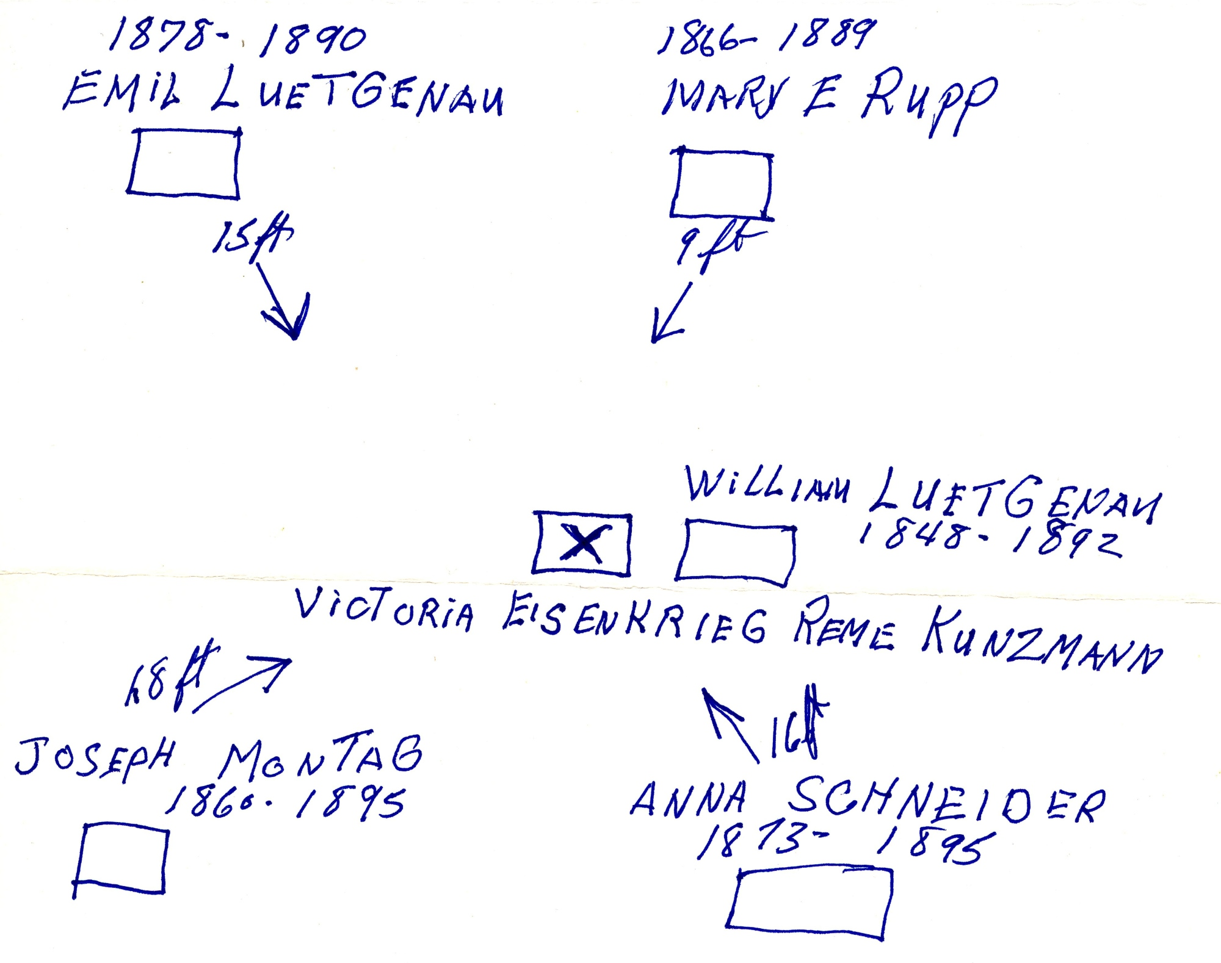

This diagram made by Charles Richard MOORE shows the location of Victoria KUNZMANN’s grave in the Mary Magdalene cemetery in Omaha. The other marked stones are large ones that can be easily located. The stone identifies her as Victoria Kunzmann and lists the names of her three sons.

ADDENDUM TWO

Articles and Obituaries of the Samuel REMER line

IS HELD ON FORGERY CHARGE

Ed McDonald is the name given by a prisoner at the city jail who is being held on a charge of forgery. Sam Remer caused McDonald’s arrest, but it was not until he became suspicious at the number of checks McDonald appeared to have about his person. Within the last day or two Remer has cashed three checks amounting to $35. The first check presented was signed W. L. Larson and was for $7.50, then came another with the signature of Charles P. Stanley for $17.60 and later one for $10 bearing the signature of W. D. Gerald. All of these checks were drawn on the Omaha National bank and had been returned stamped “no funds.”

McDonald showed up at Remer’s saloon yesterday afternoon and spent a small sum for drinks. Remer knew then that the cheeks were bogus and tried to detain his man while he sent for a policeman, but McDonald appeared to be in a hurry and started for a street car. Remer followed him and after McDonald was comfortably seated he called Officers Montague and Rowley and the arrest was made. McDonald was seen by a reporter of The Bee at police headquarters yesterday afternoon. He was pacing up and down the bullpen In his shirt sleeves and was decidedly nervous. In answer to questions he denied positively having forged the names of anyone to checks and asserted that he was being Illegally held. When searched,

McDonald had only 10 cents In money on his person, but he had some documents which may prove of value to the prosecution when his trial comes up. McDonald has a business air about him which would make it easy for him to obtain money on a check here, as a large proportion of the business transacted here is done by check. It Is asserted that McDonald is wanted in Omaha on the same charge.

- The Omaha Daily Bee – Sunday 29 January 1899 – page 5

(Untitled)

Remer, Zeller and Marcus appeared in police court yesterday afternoon to answer to the charge of violating the mayor's orders in connection with the sale of liquors. No complaints had been filed on account of City Attorney Montgomery being engaged in the district court, consequently all of the cases went over. Judge Babcork cited Sam Remer to appear at 4 o'clock this afternoon while he put the Zeller and Marcus cases over until next Tuesday.

In the Zeller case the judge expressed himself as follows: "Mr. Zeller, you will be permitted to run your restaurant without hindrance, but you must not sell a drink of any kind to any one. Further, you must place a curtain about your bar." 'No one seems to know why the city attorney or some representative of the city government has not filed complaints against these saloon keepers. It is thought that by Tuesday the necessary complaints will have been filed and that the cases will be proceeded with.

Unless the arresting officers make good their charges there will be a good chance for suit on policeman's bonds, as Remer and Marcus were kept in jail for several hours. When a friend of Remer's appeared at the jail to bail him out he was thrown in for disorderly conduct, but the police assert that they had good reason for this. Zeller was not kept in custody any length of time, but Mayor Ensor stated that he had plenty of evidence to show that beer had been sold in collee cups. Naturally the defense expects that the city will produce its evidence and also file complaints.

The Omaha Bee – 21 April 1899 – page 5

Young Remer Killed

Last Tuesday forenoon Charles E. Remer, son of Mr. and Mrs. S. S. Remer, was accidentally shot and killed while en-route from Craterville to Lawton. Remer got out of the wagon to open the gate and in some unaccountable manner the gun was discharged and the charge of shot at close range cut an awful wound in the young man’s thigh. The wound would not have been necessarily fatal if the blood could have been stopped but there was no means at hand and ere medical assistance could be obtained death came from loss of blood. It is such cases of the sudden taking of they young and strong that appeals most strongly to the sympathetic heart. The bereaved family have the heartfelt sympathy of all in this time of sorrow.

https://www.findagrave.com/memorial/62221853/charles-remer#

Obituary of Charles Anthony POKORNY (Grandson of Samuel REMER)

Charles Pokorny, 67, long-time Ada, OK resident, passed away Saturday, September 6, 2008, in Tulsa, OK. Charles lived in Ada for 60 years before moving to Tulsa, OK in 2001. He was born December 20, 1940, to Edward and Arita Pokorny in Ada, OK. After graduating from Ada High School in 1959, he attended East Central University in Ada, receiving a Bachelors Degree in General Business and a Masters Degree in Human Resources. On November 15, 1963, he married Lou Ann Pybas. He worked for the First National Bank, the Pepsi-Cola Company, and East Central University (ECU) while in Ada. He established the ECU purchasing office in 1970 and was the Assistant to the Vice President for Fiscal Affairs until he retired in 2001. He was on the Development Team of the ECU Foundation, Inc. He was co-founder and the first President of the Oklahoma Association of Educational Buyers. He was the regional advisor for the Educational and Institutional Cooperative Service and President of the Texas-Oklahoma-Arkansas Regional Group of the National Association of Educational Buyers. He lettered in tennis at Ada High School and ECU, and enjoyed playing with the Tulsa Senior Tennis Group. He was an active member in the Ada First United Methodist Church, President of the Jaycees, and a Lion's Club Member. He was preceded in death by: both his mother and father; brother, Arthur Pokorny; and sister, Edrita Oden. He is survived by: his loving wife, Lou Ann of the home; 2 daughters, Debra Yalch (Joe) of Tulsa, and Brenda Pannell (Ryan) of Branson, MO. Also survived by: 5 grand- children; cousins, aunt, nieces, and nephews. Service was at 11 am, September 11, 2008, at Faith United Methodist Church, Tulsa, OK. Ashes will be interred at Rosedale Cemetery, Ada, OK at a later date.

Obituary of Leon REMER (great-grandson of Samuel Remer)

Leon Remer, 75, of McAlester, OK passed away Saturday, August 20, 2016 in Keota, OK. Leon was born February 24, 1941 in Spiro, OK to Fred James & Helen (Williams) Remer. He was a sales clerk for Davis Bldgs. Leon was a veteran of the Army National Guard. Survivors include his wife, Margaret Jane Remer of the home; children, Glenn Powers, Ricky Powers, Tannyia Crase; 8 grandchildren, Dustin Powers, Clayton Powers, Lacey Reed, Mandi Harris, Allen Arter, Amber Simpson, Brittni Chronister, Bradlee Chronister; 13 great grandchildren; sister, Edwina Burroughs; special aunt & uncle, Lonnie & Betty Davis; special cousin, Ray Davis; other relatives, loved ones and friends. A Celebration of Life will be held at 6:30 pm, Friday evening at Evans Chapel of Memories, Poteau, OK. Please feel free to dress in your OU 'gear'. Leon would love it.

Article on Murder of Robert REMER (grandson of Samuel)

Fugitive Suspected In Theft
Robby Trammell
Published: Thu, December 28, 1989 12:00 AM in The Oklahoman of Oklahoma City

SALLISAW - A suspect in the Christmas Day killing of a longtime Sequoyah County businessman and the wounding of his wife allegedly stole a pickup truck from a couple at Spiro early Wednesday, authorities said. Gary Wayne Cloud, 36, of Panama is being sought on charges of first-degree murder and shooting with intent to kill. He is accused in the shooting death Monday of his father-in-law, Bob Remer, 64, owner of a meat processing plant near Sallisaw, and the wounding of Remer's wife, Jane, who was grazed in the hip by a bullet. She was treated at a hospital and released. Spiro police chief Darrell Barham said Cloud allegedly threatened a couple and stole their pickup truck at a machine shop near Spiro at 9 a.m. Wednesday. Cloud told the pair he had a gun, but they did not actually see a weapon, Barham said. Authorities said the suspect fled in the couple's red and white 1990 Chevy S-10 pickup bearing license tag number LRH-051. There was an unconfirmed sighting of the vehicle later Wednesday in the Fort Smith, Ark., area, Barham said. The state medical examiner's office said Remer died of gunshot wounds to the chest and abdomen. He was shot twice with a .22-caliber pistol, officials said. Sequoyah County Sheriff Wade Stovall said Cloud apparently was upset about marital problems he was having with Remer's stepdaughter. The couple had separated and possibly were in the process of getting a divorce, he said.

https://oklahoman.com/article/2301543/fugitive-suspected-in-theft

Man Gets Life Sentence For Killing Former In-Law

Sally Maxwell – 31 January 1991 – in The Tulsa World

SALLISAW - Gary Wayne Cloud, 36, was convicted Wednesday of first-degree murder in the shooting death of his ex-father-in-law, and given a life prison term. A Sequoyah County jury also convicted Cloud, of Panama, of shooting with intent to kill his ex-mother-in-law, and gave him a 20-year prison term. District Judge Bill Ed Rogers set formal sentencing for 10 a.m. Feb. 28. Defense attorney Mike Daffin said he will appeal the verdicts. Cloud was convicted of shooting Bob Remer, a Sallisaw businessman, on Christmas Day 1989. A state witness said Cloud barged into the Remer home and shot Remer twice. The witness said Cloud then shot Mrs. Jane Remer in the kitchen, wounding her in the hip. Cloud testified that he shot Remer in self defense. He said he went to the Remer home looking for his ex-wife, Debbie, who was to have dinner with him that afternoon. He took a gun because Remer carried a gun, Cloud said. When he entered the Remer residence, Cloud said Remer reached for a gun on a table next to his lounge chair. Cloud said he grabbed Remer's gun and fired twice at Remer in self defense. Cloud said he then fired at a noise in the kitchen, dropped his weapon and fled. Prosecutor Scott Hickman said the state did not have to prove a motive for Cloud. Hickman said evidence showed Remer was shot as he sat in the lounge chair.

https://tulsaworld.com/archive/man-gets-life-sentence-for-killing-former-in-law/article_84d710d1-5ba7-552c-abfb-0481133f478e.html

Obituary of Virginia Jo REMER RHOADS (widow of Robert REMER)

Virginia Jo Remer Rhoades was born on October 25, 1925, in Spiro, Oklahoma to Frank and Allie Mae Statham. She passed away on June 2, 2014, in Poteau, Oklahoma at the age of 88. She is survived by Three Daughters Eady Joann Remer of Tulsa, Oklahoma Sharron Kaye Hiatt and husband, George of Kirksville, Missouri Kerry Nan Olive of Poteau, Oklahoma One Son Sam T. Remer of Vancouver, Canada, numerous Grandchildren, Great Grandchildren, Great Great Grandchildren, Sister~In~Law Betty Davis and husband, Lonnie of Stigler, Oklahoma. Virginia was a member of the First Methodist Church and Eastern Star. She was also the business owner and operator of Remer's Market in Spiro, Oklahoma in the years past. Virginia was preceded in death by her husbands; Edward A. Remer and Haskell L. Rhoades; a sister, Dora Ella Davies; and two brothers; Bill and George Statham.

https://www.mallorymartinfuneralhome.com/obituary/6283269

ADDENDUM THREE

Articles and Obituaries of the Michael REMER line

An untitled article on the legal trouble Michael got into in December 1901.

Mike REMER, who has been operating a saloon for the Krug Brewing company at 2605 N Street, is among the missing. It was stated yesterday that on Tuesday last he was given $400 by the Krug people to use in cashing packing house checks. Instead of applying the money given him to business purposes REMER shoved it down his jeans and went south. The Krug company employed a couple of detectives to investigate with a view to locating Mr. Remer.
Omaha Bee – 29 December 1901 – page 8

‘Tuesday last’ would have been Tuesday, December 24th. South Omaha’s Czech language newspaper, Pokrok Zapadu, contains a short piece mentioning Michael in the 01 January 1902 issue. I was able to translate it using Google translate:

Mike Remer, who ran the inn for Krug Brewing Co., has been missing since Tuesday night. He allegedly received $400 from Krug the same day, so that employees in the South Omaha factories are waiting for the money to change their money, but Remer disappeared without a trace. Krug is said to have hired several secret companies to track down Remer's whereabouts.
Pokrok Zapadu – 01 January 1902 (Translated on Google Translate)

The 24 January 1902 issue of the Omaha Bee (page 5) has a long list of at least two hundred people indicted between December 21 and January 18. The list for December 24 includes Mike REMER. Most of the individuals, including Mike, had posted $200 bail. Around seventy-five people were arrested on December 24th. This was part of a long article that began on page one under the heading “Inquisition Comes to and End” that describes the work of a grand jury in processing over three hundred total indictments mostly involving people keeping illegal slot machines. However, Michael’s indictment was probably linked to the $400 that he allegedly tried to steal. I couldn't find anything more about this so have no idea if he was guilty or just what actually happened.

The Krug Brewery was the largest brewery in Omaha at the time. It later became part of Falstaff, which was in turn absorbed by Anheuser-Busch.

Obituary of Robert J REMER

Robert J. "Bob" Remer, 78, of Sioux City died Monday, May 22, 2006, at Indian Hills Nursing and Rehab Center. Services will be 10:30 a.m. Wednesday at St. Michael Catholic Church, with the Rev. Gary Snyder officiating. Entombment will be in Calvary Cemetery Mausoleum. Visitation will be 3 to 8 p.m. Tuesday, with the family present 6 to 8 p.m. and a vigil service at 7 p.m., at Meyer Brothers Colonial Chapel. Robert was born Dec. 8, 1927, in Minneapolis, Minn., the son of Walter and Myrtle (Olson) Remer. He grew up in Sloan, Iowa, where he attended school and two years of college through I.P.S. He served in the U.S. Navy during World War II. He married Marian A. Beeson on May 11, 1949, in Sioux City. Bob worked for I.P.S. (now MidAmerican Energy) for 40 years and retired in 1990. He was a member of St. Michael Catholic Church and the American Legion, Casper Post 477 of Hinton, Iowa. He enjoyed gardening, hunting, fishing and doing woodworking. Survivors include his wife, Marian of Sioux City; a son, Steven Remer and his wife, Jackie of Homer, Neb.; a daughter, Laura Wheeler of Sioux City; a sister, Donna Hughes and her husband, William of Palm Springs, Calif.; a niece, Patty; six grandchildren, Steven Remer Jr., Corey Remer, Amanda Schlotman, Kyle Rohde, Andrew Rohde and Mitchell Rohde; and four great-grandchildren, Autumn Joy, Tyler, Megan and Jennifer. He was preceded in death by his parents; and two sisters, Doris and Irene. Pallbearers will be Steve Remer Jr., Corey Remer, Kyle Rohde, Andrew Rohde, Mitchell Rohde, Josh Schlotman and Ed Rohde.

https://siouxcityjournal.com/news/local/obituaries/robert-bob-remer/article_4049066d-efc1-5933-8b6c-87e2e62d72fe.html

Obituary of William HUGHES, husband of Donna Lou REMER HUGHES

William R. "Bill" Hughes, 80, formerly of Sioux City passed away Dec. 30, 2006 in Palm Springs, Calif. Services will be 10 a.m. Saturday at St. Theresa Catholic Church in Palm Springs. Burial will be in Riverside Veterans Cemetery. Bill was born in Sioux City, the son of Mark and Eulalia (Garretson) Hughes, who were partners with Jack Zuparn of Zuparn-Hughes Drug Store at Fourth and Pearl streets for many years. He attended Blessed Sacrament Grade School and Trinity High School. He enlisted in the U.S. Navy. He was in real estate in California for many years. He is survived by his wife, Donna (Remer) Hughes; their four children; a brother, Mark Hughes Jr. of Springfield, Va.; and a sister, Joanne (Hughes) Salem of Colorado Springs, Colo.

https://nebnewspapers.unl.edu/search/pages/results/?county=Douglas&city=Omaha&yearRange=1882-1895&frequency=&language=&rows=20&sort=revelance&proxtext=mertes&proxdistance=&ortext=&andtext=&phrasetext=&date1=&date2=

SUBJECTS FOR FURTHER RESEARCH

1) Employ a professional genealogist in Germany to find out exactly where the Remer Brothers came from in Bavaria.

2) Use resources at the Omaha Library to figure out exactly how addresses in South Omaha changed after it was annexed to Omaha. Then use that information to locate places the family lived and worked in South Omaha. Also map out locations in North Omaha.

3) More research in Omaha newspapers of the era. It would be especially interesting to find out more about the beef-skinning contests.

4) Locate descendents on other lines in hopes that they can provide other information. Perhaps they might have photos of Samuel or Michael or maybe even the boys' parents.

5) Research Comanche County, OK property records for records that might indicate when Samuel moved there and when he moved away.

6) Research Sarpy County property records around 1894 to see if there are records of Samuel living in or near Springfield.

7) Continue to search for records of missing children of Samuel.

SELECTED LINKS

Description of Harris & Fisher packing house
http://www.kancoll.org/books/andreas_ne/douglas/douglas-p22.html

The University of Nebraska at Lincoln has a number of old newspapers online.
https://nebnewspapers.unl.edu/newspapers/

The Library of Congress has old maps online. This link is for the index to Nebraska. They can be further narrowed by county.
https://www.loc.gov/maps/?all=true&dates=1900-1999&fa=location:nebraska&st=gallery

North Omaha 1934 Maps: https://www.loc.gov/item/sanborn05229_005/
South Omaha 1900 Maps: https://www.loc.gov/resource/g4194om.g05229190103/?sp=1

Links At Ancestry.com
These links will only work if you have an account at Ancestry or are accessing from a library that has an Ancestry subscription.

Samuel Remer Family
https://www.ancestrylibrary.com/family-tree/person/tree/12658535/person/-209367932/facts?ssrc=

Anna and Otto PRILL Family
https://www.ancestrylibrary.com/family-tree/person/tree/58459702/person/34102416944/facts?ssrc=

