THE MERTES-DISCH LINE

This document outlines what is known about the maternal family line of Helen REMER (1907-1991), wife of Charles Franklin MOORE. Helen’s mother was Mary Ann MERTES, daughter of John Peter MERTES and his wife Marie Therese DISCH. For Helen’s paternal family line, see the document on the REMER family.

Edition: September 2021. This document will be updated as new information is known.

CONTENTS

2 – Photo of the John Peter MERTES family, about 1900
3 – John Peter MERTES
4 – Marie Therese DISCH
5 – John Peter and Therese's Children and Grandchildren
9 – The Ancestry of John Peter MERTES
12 – The Ancestry of Marie Terese DISCH
16 – The Mary Magdalene Church
17 – The MERTES Family by Charles Richard MOORE
18 – The Joseph BAUST story
19 – Memories from Joanne HEIM DAVIS

RESOURCES

Much of the information here came from the research of various members of the Terese Frances DISCH line. These pages can be found on Ancestry.com, but you will need to have an account or else use a public library account.

Reed Family Tree:
https://www.ancestrylibrary.com/family-tree/person/tree/4303879/person/-192255430/facts

HappyHeartHans Tree
https://www.ancestrylibrary.com/family-tree/person/tree/31953989/person/20476629639/facts

Prill-Wilson-Cothran Tree
https://www.ancestrylibrary.com/family-tree/person/tree/163758972/person/222130769081/facts

Heim Family Tree
https://www.ancestrylibrary.com/family-tree/person/tree/3106660/person/-1597285215/facts

The John Peter MERTES Family about 1900

Front: parents Marie Terese DISCH and John Peter MERTES
Rear: children Teresa Frances, Peter Nicholas, Mary Anna, Margaret Mary

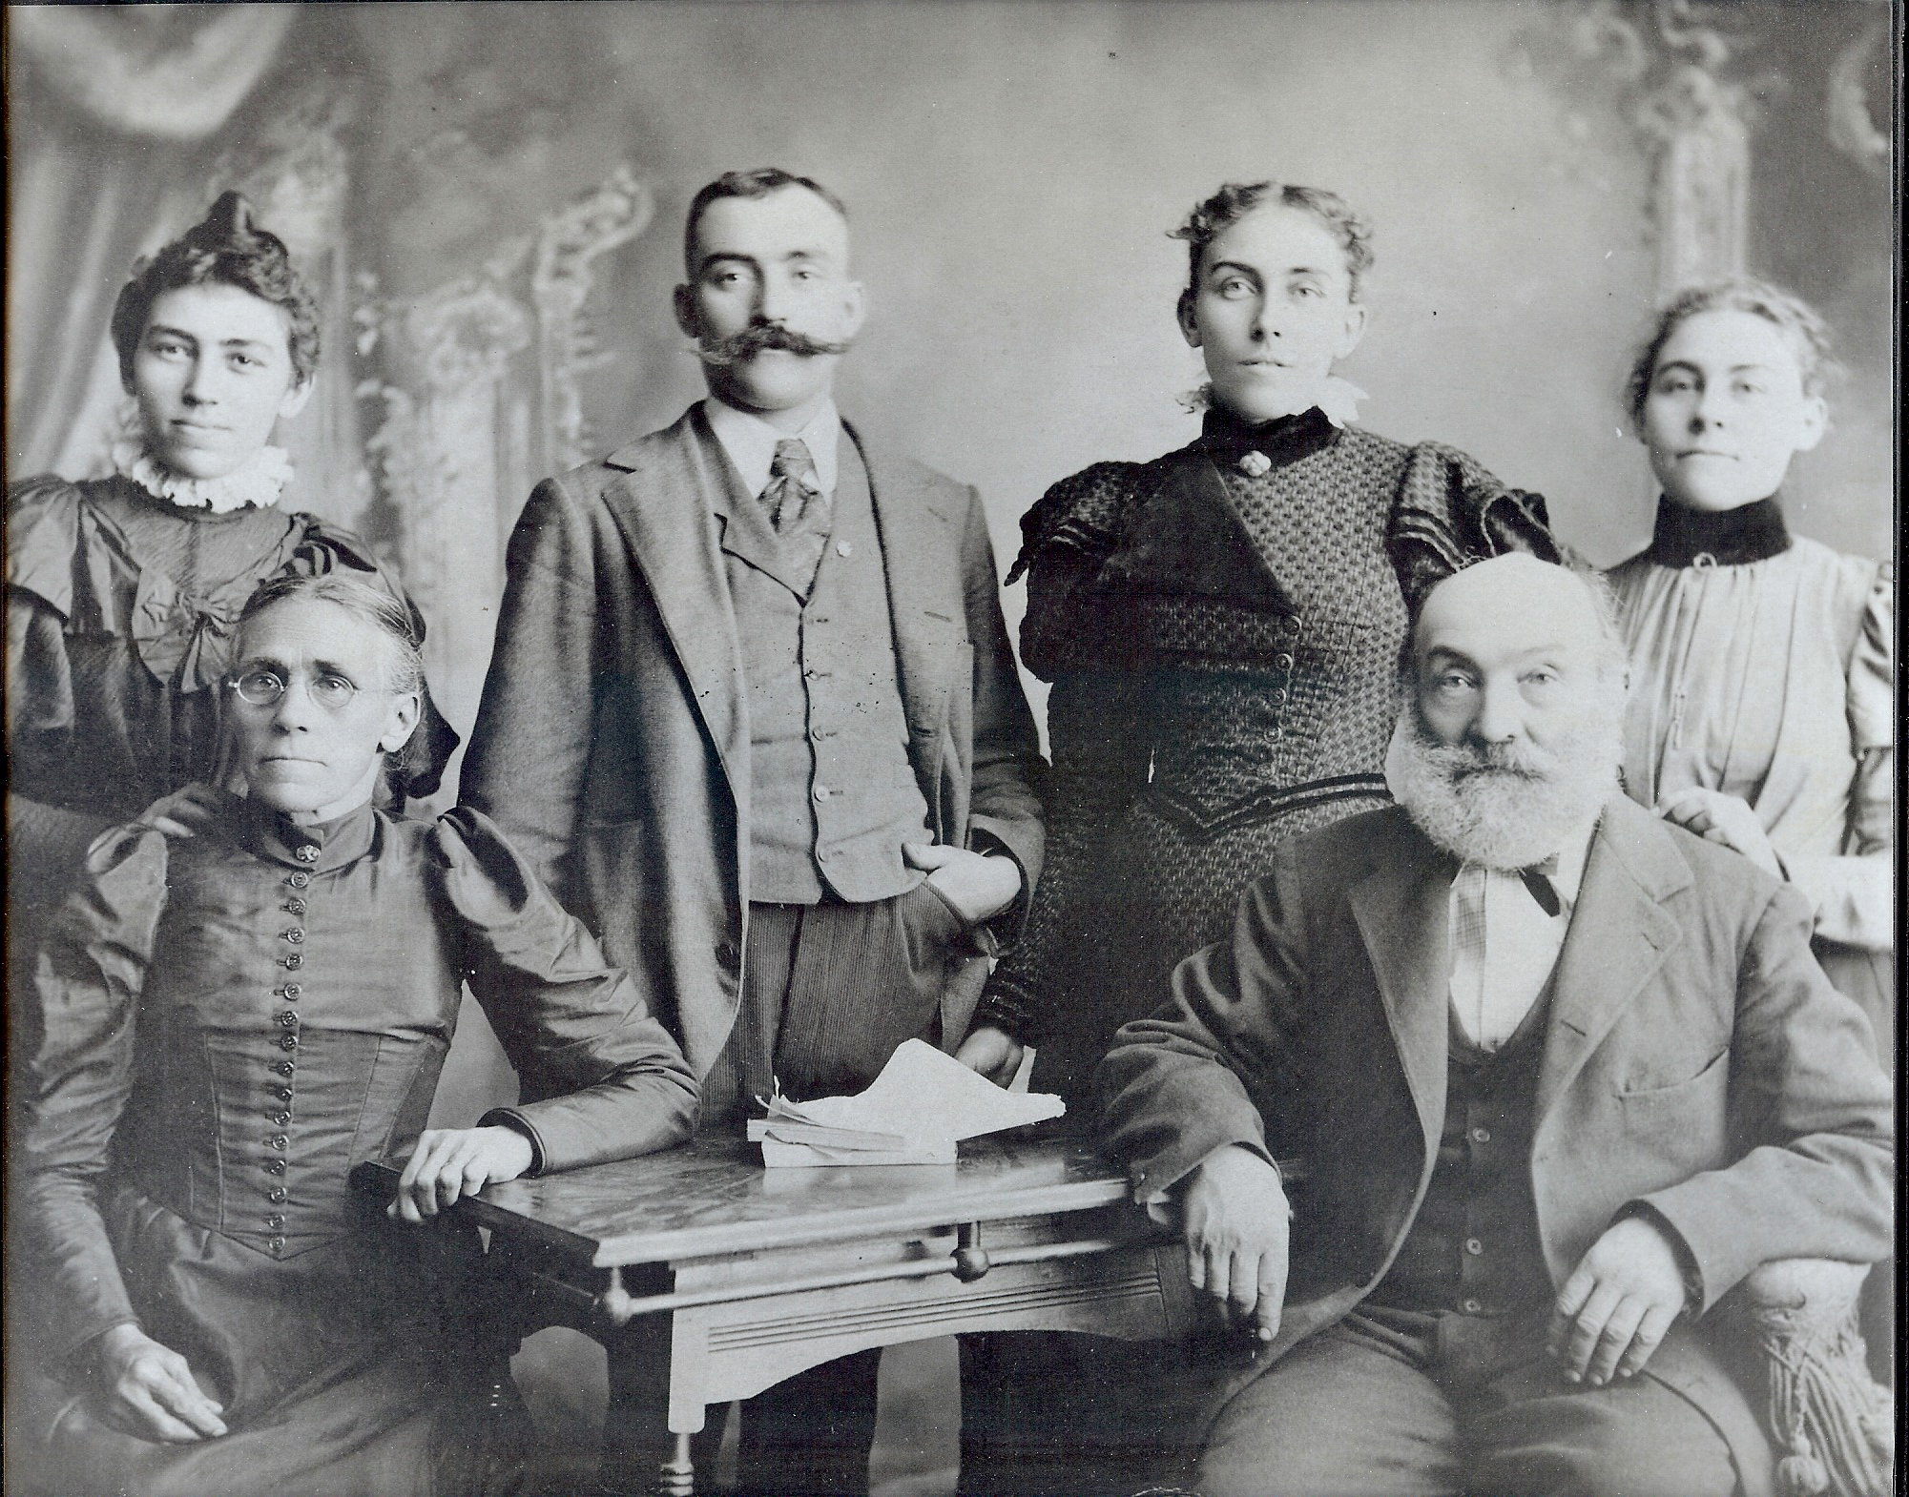

John Peter MERTES

Per the ages given in census records, John Peter MERTES, father of Anna, was born around 1836 in Germany. His birth year is listed as 1836 in the 1900 census.

Like his wife and daughters (and many in the REMER family), John often went by his middle name of Peter except in official documents.

John came to the USA in 1865 according to the 1900 and 1910 census. He is probably the John MERKLE listed as arriving in New York City on 22 August 1865 on the vessel Borussia out of Hamburg. He was listed as a 28-year-old farmer, so the age would match.

On January 3 1869 he married Marie Therese DISCH in Omaha. (Some sources list 28 December 1868. That was the day they got their marriage license.) The couple would have three daughters and one son.

In the 1870 census John Peter is living in Second Ward, Omaha and working as a laborer. Also in the house are his wife Therese (35) and daughter Anna (6 months). The value of his estate is given as $1000.

John Peter is first found in the Omaha city directories in 1870. He listed as Peter MERTES, laborer, boarding at 19th Street near the UPRR tracks. He worked for Morrell & Ramsey, which was listed as a soap and candle manufacturer and also located around 19th and the UPRR tracks.

On April 1, 1871 John Peter filed his intention to become a US citizen in Douglas County.

John Peter is not listed in the1872 directory but in 1874 is still a soap maker at Morrell & Ramsey. He was living at 222 18th Street in Omaha. In 1876 he is at 18th and Williams and working as an ‘expressman’.
In 1878 he is working as a gardener and residing at 28th and Harney. In 1879 he is listed as a gardener and residing at 415 South 29th.

In the 1880 census the family consists of John P (44), Theresa (42), Mary Anna (10) Peter Nicholas (8), Mary (5), and Francis (2).

In the early 1880s the family moved south to the Summit neighborhood where the REMER brothers mostly resided. John Peter is missing from the 1881 and 1884 directories. In 1883 he is listed as a laborer living at 26th by the UP tracks and then at the 30th and the UP tracks in 1885.

In 1886 eldest son Nicholas is listed in the directory as an employee of the Harris and Fisher Packing House (where the REMER brothers worked). John Peter is not listed that year. He reappears in 1887 when he and eldest daughter Anna are listed as employees of Harris and Fisher.

The Mertes family disappears from the directories for a few years. In 1892 son Nick is listed as living at 15th & A. He is working as a butcher for Hammond.

In 1893 the family is living at 13th and 2nd in South Omaha. Nicholas works at Swifts but no job is listed for John P. Also in the household is “Daisey MERTES”. This must have been a nickname for the youngest daughter, Teresa Frances, who was still at home.

In 1895 the family is at 1553 Z Street. In 1896 they are at 1336 Z. Most of the family would relocate to that block.

In the 1900 census the family is listed at 1347 Z. The household consists of John, who is retired, wife Theresa, and son Nicholas (employed as a butcher).

After his wife died in 1903, John Peter moved in with the family of his daughter Anna and her husband Charles REMER. He is listed in the REMER household at 1318 Z in the 1910 census.

John Peter died in Omaha 2 November 1916. He is buried in Mary Magdalene Cemetery in Omaha.

According to Charles Richard MOORE, his mother Helen REMER remembered her grandfather as a kindly Santa Claus like man. The few pictures we have, taken later in life, show him with a fuzzy white beard so he even looked a bit like Santa Claus.

Marie Therese DISCH

Her maiden name of DISCH comes from her marriage record with John Peter MERTES and from the marriage record of her daughter Anna with Charles REMER.

Her first name is variously given as both Mary and Marie while the middle name is spelled either Therese, Theresa, or Teresa. Generally the first spelling is used. Usually she went by her middle name.

Therese was born in January 1838 according to the 1900 census. She was born in Alsace, France according to Federal census records and the 1885 Nebraska state census. Her family background is explained below.

Marie Therese came to the USA in 1866 according to the 1900 census.

On 3 January 1869 she married John Peter MERTES in Omaha. They would have three daughters and one son.

Marie Therese died in South Omaha on 4 February 1903.

According to Charles Richard MOORE, his mother’s older brothers remembered Therese as being a sour and mean woman, not much different from her daughter Anna, who was their mother.

John Peter and Therese’s Children and Grandchildren

Mary Anna MERTES
Born 11 January 1870 in South Omaha.
Married Charles REMER on 27 April 1887.
Died: 1 December 1947 in Omaha. Buried in Mary Magdalene Cemetery.
See documentation on the REMER family for details of her descendents.

Peter Nicholas MERTES
Born: 26 February 1872 in South Omaha
Uncle Nick (as Helen REMER MOORE remembered him) never married. He lived with his parents until his mother’s death in 1903. After that he lived in rooming houses.
He worked as a butcher in various packing houses in Omaha.
Died: 1926 in South Omaha. Buried in Mary Magdalene Cemetery, Omaha.

Mary Margaret MERTES and children

Mary Margaret MERTES was born on 19 February 1875 in Omaha.

She married George Henry BAUST on 23 November 1892 in Omaha. George was born 12 January 1865 in Pittsburgh, PA. He was the older brother of Joseph BAUST who married Teresa Frances MERTES.

George and Mary lived in Omaha until at least 1937 (the last year George is listed in the Omaha city directory). In the 1940 census the family is living in Oakland, Alameda County, California with daughter Marcella and her husband.

George died 3 December 1946 in Alameda County. Mary Margaret died on 11 January 1961 in San Leandro, CA. She is buried in Hayward, CA.

Children of Mary Margaret MERTES

Edna Jeannette BAUST
Born May 1893 in Omaha. Died 1900 in Omaha.

Milo Edward BAUST was born 24 May 1895 in South Omaha. He is isted with wife Eva (age 42) in Omaha in 1940 Census. Also in household were two step-sons, John (22) and Edward (20) KENNEDY. Milo died 19 June 1959 in Alameda County, California.

Milton Eugene ‘Henry’ BAUST was born 20 June 1897 in South Omaha.

He married Marie E. GRASKY in Sioux City, Iowa on 28 April 1924. They resided in Sioux City from about 1924 until 1927 before moving back to Omaha.

Milton is listed in the 1930 Omaha census with Marie (26) and daughters Betty A. (4 yrs 8 mo) and Rita M. (2 yrs 1 mo.)

The family moved to Sacramento, California about 1938 and are listed there in the 1940 census under the name Henry. The family included children Elizabeth (14) and Rita Marie (12). Milton died 2 October 1958 in San Francisco.

Mary Irene BAUST was born 28 June 1899 in South Omaha.

At an unknown time and place (probably Omaha in the early 1920s) she married Edward Stanley GORMAN (born 8 November 1898 in Omaha). The couple had one child, son Patrick John GORMAN, born 8 April 1927 in Omaha.

In the late 1930s the family moved to Los Angeles, CA and are listed there in the 1940 census. The household consists of Stanley (39), Irene (40), Patrick (13) and Stanley’s brother and sister-in-law, Joseph N and Edna R GORMAN.

At some point the couple moved back to Omaha. Stanley died 8 April 1969 in Omaha and is buried in Calvary Cemetery. Mary Irene died in April 1994 in Omaha.

Son Patrick GORMAN married Genevieve SALERNO (1926-1996) on 28 June 1952 in Los Angeles. They had one known child, Lucia Mary GORMAN (1954-2001). Patrick died 28 March 1990 in San Bernardino, CA.

Marcella Lorraine BAUST was born 28 December 1901 in Omaha.

At an unknown time and place (probably Omaha in the late 1920s), she married Frank Harry (‘Frank Huzz’) HOWARD (born 4 April 1901 in Omaha).

The couple had three children: Mary (born about 1931); Mortimer (born about 1933); and James Francis (born 25 October 1934 in Omaha and died 22 October 2011 in Alameda County, CA). According to Joanne HEIM DAVIS, Mary maried a man named LOWENTHAL.

The couple moved to Oakland, Alameda County, California around 1935. The parents, their three children, and George and Margaret BAUST are listed living together in the 1940 Alameda County census.

Frank Harry died 5 October 1983 in Oakland, CA. Marcella died 11 February 1987 in Lafayette, Contra Costa County, California. She is buried in Queen of Heavens Cemetery.

Margaret BAUST was born 18 July 1904 in South Omaha. She married a man named SOUZA. They are probably the Margaret (born in Nebraska) and Manuel SAUZA listed in Alameda County in the 1940 census. There were no children in the household. Margaret died 8 June 1988 in Alameda County, CA.

Gertrude Hannah BAUST was born 13 October 1906 in South Omaha. In the 1940 census she is living alone in San Francisco and working as a stenographer for a petroleum company. She never married. In 1990 was living in Walnut Creek, CA. She died 15 April 1998 in Walnut Creek, Contra Costa County, CA.

Marie Clair BAUST was born 19 October 1910 in Omaha.

She married Robert James CONNELLY in Omaha on 22 April 1933. Robert was born 1 January 1901 in Warnerville, NE. The couple lived in Omaha all their lives.

Robert Sr. died 24 January 1988 and Marie on 7 June 2003. They are buried in Calvary Cemetery in Omaha.

They had two children. Robert James CONNELLY Jr. (5 December 1934 to January 2012) and Terrence M CONNELLY (28 February 1937 to 20 Janaury 2012).

Frank Aloysius BAUST was born 26 September 1912 in South Omaha. Frank moved to California with parents in late 1930s. He died 3 April 1981 in Jamestown, Tuolumne County, California. It is not known if he married or had children.

Teresa Frances MERTES and children

Teresa Frances MERTES was born on 14 May 1878 in South Omaha.

On 16 April 1896 she eloped to Council Bluffs, Iowa with Joseph BAUST. Joseph was the younger brother of George BAUST, husband of Teresa’s sister Mary Margaret. Joseph was born 1 January 1871 in Philadelphia, PA. In the 1900 census the couple live at 1327 Z Street, next door to sister Anna and her husband Charles REMER. The household includes daughter Irene, born February 1899. Joseph is a butcher.

Joseph is last listed in the Omaha city directories in 1905. It’s not known what happened but in the 1910 and 1920 census he is listed as a patient in the insane asylum in Adams County, Nebraska. He would die there on 11 August 1933.

Sometime after that Teresa met and formed a relationship with Henry Martin FISHER. Henry was a previous resident of Omaha but had been living in California.

Sometime after that Teresa and her three children moved to Los Angeles, California. She would live the rest of her life in the Los Angeles area.In the 1910 census she and her children are listed as the family of Henry Martin FISHER in the Los Angeles, California census. She and Henry would be a couple until Henry’s death but were not able to marry until after Joseph BAUST’s death. Henry and Teresa were married in a civil ceremony on 7 September 1933 in Yuma, Arizona and then in the Catholic Church in Los Angeles on 17 March 1934.

Henry Martin FISHER was twenty years older than Teresa, being born on Lexington, Missouri on 17 January 1860. He briefly lived in Omaha around 1889 before moving to California in 1892. Henry died on 8 July 1937 in Maywood, Los Angeles, California.

On 9 November 1940, Teresa Frances married Merrill Erastus WILLIS Jr. Merrill was born 18 August 1871 in Toquerville, Utah and had come to California in the 1920s. He died 22 January 1955 in San Gabriel, Los Angeles County, California.

Teresa died on 27 March 1971 in Glendora, Los Angeles, California. She is buried in Calvary Cemetery, Los Angeles.

Children of Teresa France MERTES

Teresa Frances had four children to Joseph BAUST and one to Henry Martin Fisher.

Leonard BAUST was born 10 June 1897 in South Omaha and died in July 1897.

Eileen Agnes BAUST was born on 5 January 1899 in South Omaha. Eileen would marry five times. She has no known living descendents.

In 1915 Eileen married Walter KNEILING in Los Angeles. They had one child, Elmer Walter KNIELING (1915-1921). They divorced sometime around 1918. On 17 March 1920 she married William V. EMORY in Los Angeles. It’s not known if this ended in divorce or if William died. About 1922 she married Orville Henry TOMPKINS. Orville was in the US. Navy and the couple moved back and forth between California and Hawaii. She divorced Orville sometime in the early 1930s. By 1936 she was married to William E. MURRAY. By the time of the 1940 census she was divorced again as she was listed Eileen MURRAY, divorced, age 41 in Los Angeles. She was working as a saleslady for electrical appliances.

Sometime after 1940 she married Clarence Raphael CARROLL. They would stay married until Clarence’s death in 1979. Eileen died on 15 April 1980. They are both buried in Resurrection Cemetery in Los Angeles.

Leo Harold BAUST was born 5 April 1901 in South Omaha. Around 1918 he married Murilla Christine IRELAND. They would soon divorce. About 1922 he married Ila M. MARTELL. They lived in the Los Angeles area until the 1950s and then moved to Stockton, California. Leo died on 28 January 1958 in Stockton. Ila died on 19 January 1971 in Stockton. They are not known to have had children.

Peter Nicholas BAUST was born 16 November 1903 in South Omaha. On 23 November 1922 he married Margaret J HITCH in Los Angeles. Margaret was born 3 October 1904 in Knoxville, Tennessee. The couple lived their lives in the Los Angeles area. Peter died on 7 April 1975 and Margaret on 14 July in the same year.

Peter and Margaret had three children. James, the eldest, was born about 1923. Daughter Dolores Marie was born on 10 October 1929 in Los Angeles. She married Edwin Clyde ENGLISH Jr at an unknown date in California. The couple were living in Gardena Valley, California in 1954. They later moved to Texas. Dolores died in Montgomery County, TX on 24 March 1992. Edwins died in the same county on 19 November 1999. It is not known if they had children.

The youngest son, Edward Michael, was born on 13 February 1938 in Gardena, California. He married Janet Kay RANDOLPH at an unknown time and place. Edward died 2 May 2015 and Janet on 18 January 2020. They both died and are buried in Montgomery County, Texas. They had three children: Mike BAUST (wife Pat) of Monterry, California; Jeffrey BAUST (wife Cynthia) of Roanoke, Texas; and Julie BAUST (wife of Rodney CLARK) of Spring, Texas. The locations are from Janet’s 1920 obituary.

Lydia Christine FISHER was born 5 May 1907 in Los Angeles, California.

According to her daughter, Joanne HEIM DAVIS, Lydia and her mother Teresa returned to Omaha and stayed for about six months in 1919. She even went to school in Omaha. During this time she and Helen REMER became close. The pictures of the family standing in the snow were taken at this time.

On 21 May 1924 she married Alexander Bernard HEIM in Los Angeles. Alexander had been born in Goebel-Saratov, Russia on 25 February 1904 but had come to the USA when he was two years old. He became a US citizen in 1929. The couple would live in the Los Angeles area until moving to Henderson County, Nevada in 1991. They would live there until their deaths, Alexander on 16 July 1999 and Lydia on 7 April 2003. They are both buried in Resurrection Cemetery in Los Angeles.

The couple had six sons and three daughters. They included Jeannette Christine HEIM (1925 to 2015), John August HEIM (1937 to 2007); and Alexander Christopher HEIM (1943 to 1999).

In 2001 I had some correspondence with another daughter, Joanne HEIM DAVIS. In one message she mentioned her two youngest daughters Jennifer (24) and Kimberly (19).

The Ancestry of John Peter MERTES

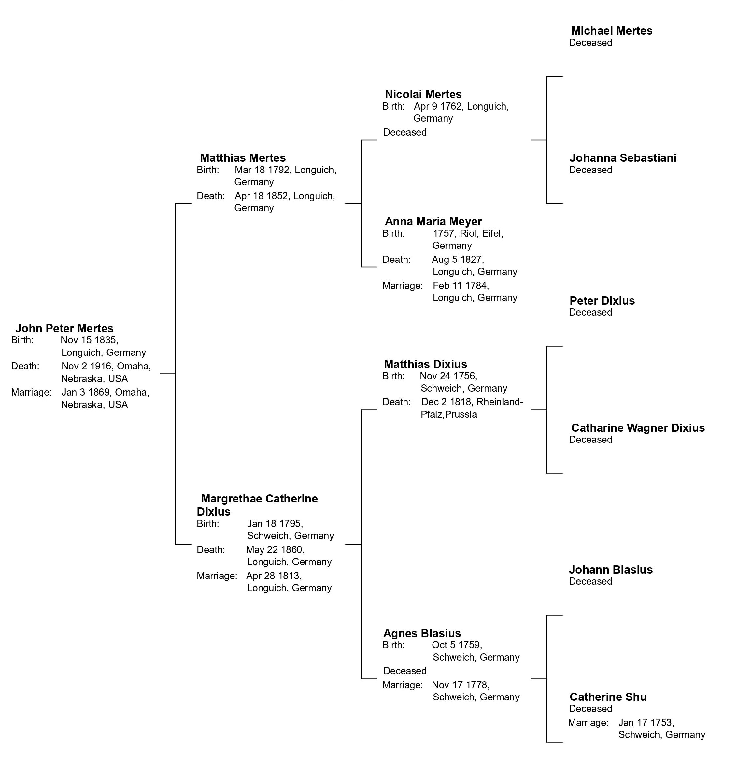
John Peter MERTES was from Germany. More specifically, 1880 federal census and his certificate of death list his birthplace as Prussia (not to be confused with Russia). The 1885 Nebraska state census says that he and his parents were born in Rhineland. Here we need a little German history.

Modern Germany did not exist as a united country until 1870. Prior to that it was made up of a number of smaller kingdoms and principalities. The largest and most important was Prussia, which roughly consisted of the eastern part of modern Germany and parts of today’s Poland, Kaliningrad, and Lithuania. The Rhineland is in a different part of Germany, along the Rhine River and bordering on modern day Luxembourg and France. For centuries the Rhineland was made up of several tiny countries until Napoleon annexed the region to France around 1800. After Napoleon was overthrown in 1815 the Rhineland became a province ruled by the King of Prussia, even though it was around 200 miles from the rest of Prussia. So John Peter MERTES was born in the country of Prussia but he was from the Rhineland region and not what is historically known as Prussia.
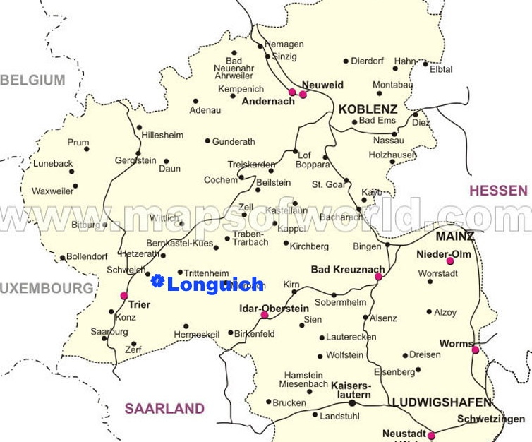
Two documents tell us who John Peter’s parents were. First, his 1916 death certificate gives their names as Matthias and Margarite MERTES. Second, John Peter’s daughter Teresa Frances left behind a note giving names of ancestors that her parents told her. She wrote that John Peter’s mother was Catherine DIXIUS and his father Joseph MERTES. About twenty years ago some of Teresa’s descendents in California hired a German genealogist to trace the family line in Germany and everything we know from Germany comes from that research.

John Peter was born in Longuich, a small town on the south bank of the Moselle River. Some of his immediate ancestors came from Schweich, just across the river to the north, and from Riol, is a small village about a mile south of Longuich. Modern day Longuich is a small town in the German state of Rhineland-Palatinate (yellow in map). The population is less than 1,500 people but the town is a minor tourism destination in the Moselle Valley wine region. Google maps shows about a dozen wineries in the little town.

John Peter’s Parents and Siblings

His father was Matthias MERTES. Matthias was born 18 March 1792 in Longuisch. Matthias married Margaret Catharina DIXIUS on 28 April 1813 in Schweich, Trier-Saarburg, Rheinland-Pfalz, Germany. Matthias died 18 April 1852 in Longuich. Margaret Catharina DIXIUS was born 18 January 1795 in Schweich, Trier-Saarburg, Rheinland-Pfalz, Germany. She died on 22 May 1860 in Germany.

Matthias MERTES and Margaret DIXIUS had eight known children: Anna Maria (6 Feb 1814 – 15 Oct 1856); Nicolas (born 24 Sept 1815), Eva Christina (born 3 Oct 1818), Anna Margaret (born 26 Jan 1821), Matthias (born 2 Jan 1823), Josef (born June 1830), Margaret (born 22 July1833), and John Peter (1835-1916). All the children were born in Longuich.

Margaret Catharina DIXIUS’ father was Matthias DIXIUS. He was born 24 November 1756 in Schweich and died there on 30 November 1818. His parents were Peter DIXIUS (bonr 21 January 1724 in Schweich) and Gertrude (born 1734 in Longuich and died 9 November 1778 in Schweich). He married Agnes BLASSIUS on 17 November 1778 in Schweich.

Margaret Catharina DIXIUS’ mother was Agnes BLASSIUS. She was born 5 October 1759 in Schweich and died there on 23 February 1827. Her father was Johann BLASSIUS (born 1742). Her mother was Catharina SCHUE (born 16 August 1729 in Riol, Trier-Saarburg, Rheinland-Pfalz, Germany).

Matthias DIXIUS and Agnes BLASSIUS had seven known children: Johann Matthias (born Sept 14 1779); Catharina (born 27 Jan 1782, died 22 May 1860); Barbara (born 1 Feb 1784); Johann Aloy (born 21 June 1786); Maria Magdalena (born 13 Feb 1790, died 24 Oct 1852); Peter (born 9 June 1792); and Margaret Catharina.

The Ancestry of Marie Terese DISCH

Mother of Mary Anna MERTES, Grandmother of Helen REMER

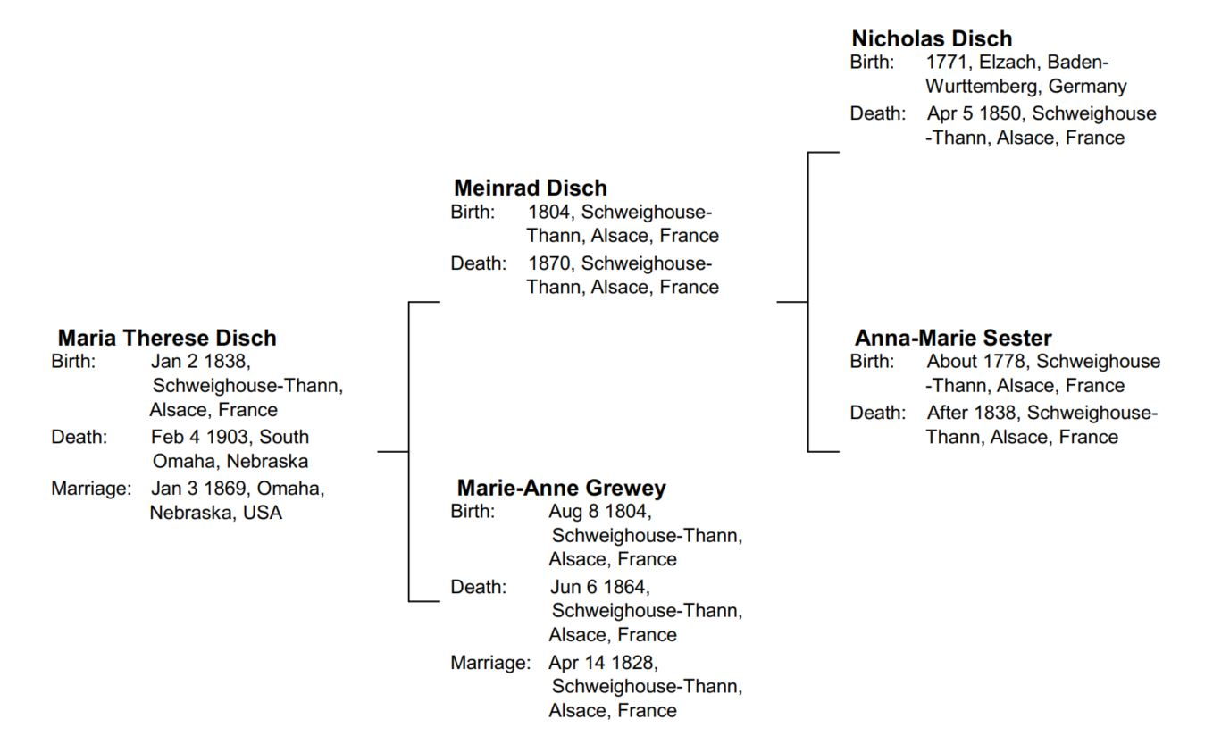

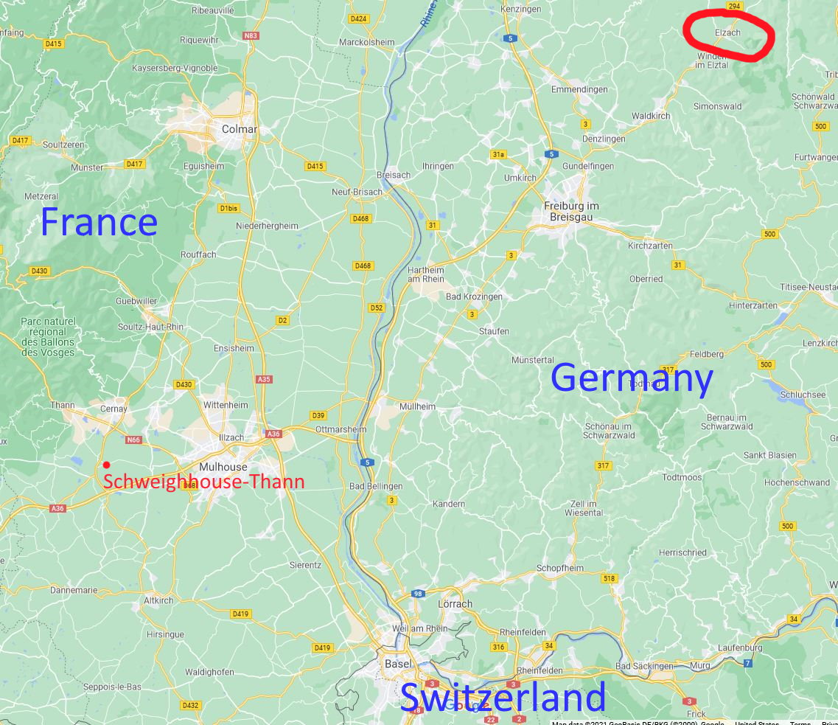
Marie Therese DISCH was one of four sisters who immigrated to the United States from Alsace, France at different times in the mid-1800s. Marie Therese arrived with a male first cousin while the other three sisters arrived on their own. However, it’s unlikely that they traveled alone as single women. They probably came with other family members of a different surname or perhaps neighbors.

Today Schweighhouse-Thann is a small town of less than one thousand people about eight miles west of downtown Mulhouse in Haut-Rhin department of France.

Marie Therese’s paternal grandfather, Nicholas DISCH, was from Elzach in what was then the small kingdom of Baden (now part of the German state of Baden-Wurttemberg). Elzach is located about fifty miles northeast of Schweighhouse-Thann in the Black Forest. The present-day population is around seven thousand.

The Immigrants

Christina DISCH

Christina, the oldest sister, was the first to immigrate. In the 1900 census she listed her arrival date as 1855, when she was 23 years old. However, the first record of her in the United States is on 1 September 1862 when she married Nicholas COLBERT in Stark County, Ohio. Nicholas, who had recently been widowed, was born in 1811 in France. The family would have three sons and three daughters, although none of the sons would live to adulthood.

In 1865, Nicholas applied for a passport to take his family back to France to visit family. The name of the witness on the application appears to be Nicholas Grevey. That’s very similar to the DISCH girls’ mother’s maiden name of GREWEY, so perhaps their mother had family in the Canton, Ohio area. Records show that the COLBERT family traveled to Europe and returned to Stark County, Ohio in July 1867.

Nicholas last appears in the 1880 census, so must have died around then. After that Christina and her children moved to Omaha. The first record of this is when eldest daughter Mary Louisa COLBERT married George SAUTTER at Mary Magdalene Church in South Omaha on 23 May 1882. Records show Christina COLBERT living at 4402 Ames Avenue in Omaha from 1891 to 1899 and then at various addresses in Omaha until her death on 2 October 1902. She is buried in Mary Magdalene Cemetery.

Mary Louisa and George SAUTTER would have one daughter, Louise Teresa SAUTTER. She would marry Frank HOLMSTEDT and have three sons and two daughters. Some of the children moved to California and it’s not known if there are any descendents still in the Omaha area.

Christina’s second daughter, Amelia Henrietta COLBERT married Emmet Hughes McCREARY in Omaha on 21 January 1896. They had one son and two daughters, all of whom lived their lives in Omaha. Son Leo and daughter Emma never married, but daughter Cecelia married Theodore KALAMAJA and had three children and at least one stayed in the Omaha area so there may still be descendents.

Christina’s final daughter, Olivia Florine COLBERT would marry James France TIMMINS at Mary Magdalene Churuch on 24 February 1897. They would have five sons and one daughter. Four of the sons stayed in Omaha so there are likely still descendents with the surname TIMMINS.

Brigitte DISCH

Brigette DISCH was the second sister to come to the United States and first to Omaha. It’s not known when she arrived but on 17 January 1865 she married Nicholas MERGEN in Omaha. Nicholas had been born in Bigelbach, Luxembourg and come to the USA in 1853. He served in the 1st Nebraska Calvary from June 1861 until August 1864 during the Civil War. The couple lived in Omaha until Brigitte’s 1905 death and Nicholas’ 1908 death. The couple had a daughter who died as an infant and one son, Philip Peter MERGEN. Philip married Elizabeth Margaret POST. The couple had four sons and three daughters who lived to adulthood. After Philip died in 1927 Elizabeth moved to San Diego and all their children lived on the west coast. There aren’t any known descendents in the Omaha area.

Marie Therese DISCH and Nicholas DISCH

Marie Therese was three years older than Brigitte but came to the USA after her. She was 27 years old and single and perhaps she heard how easy it was to find a husband. In her case, we know who she came with – a first cousin named Nicholas DISCH. The series Germans to America (volume 18, page 92) lists Nicholas DISCH, age 27, and Therese DISCH, age 30, arriving in New York from Havre, France on 17 July 1866 on the ship Missouri. In October 1868, Nicholas filed for a homestead near Fort Calhoun, north of Omaha, and married about 1 ½ years later. In 1889 he sold his farm and moved his family to Texas and then Oklahoma. His descendents live in Oklahoma and the Texas panhandle today.

Walburga Lena

The last to come was the youngest child, daughter Walburga Lena, who arrived in New York on 10 April 1871. She may have stopped off to see her sister Christina in Ohio, but her destination was Omaha. On 4 April 1871, less than six months after her arrival in the USA, Walburga married Philip MERGEN in Omaha. Philip was a younger brother of Brigitte’s husband Nicholas MERGEN. Philip had been living in Leavenworth, Kansas, since shortly after his 1864 arrival and that’s where the couple made their home. They would have two sons and two daughters before Walburga died in March 1884. A few years later Philip moved the family to Council Bluffs, Iowa, where he worked variously as a hotel manager and a bartender. He eventually moved to Oklahoma and died there. While all four children started their adult lives in the Omaha/Council Bluffs area, they all eventually moved away and it is unlikely that there are any descendents left in the area.

The Mary Magdalene Church

John Peter MERTES was one of about a dozen men who helped found Mary Magdalene Church in 1868. It was the first German church in the area. The families of the various DISCH sisters were strongly connected to the church. Below is a list of related individuals known to be buried in the cemetery. There are probably others, including some of the children who died as infants.

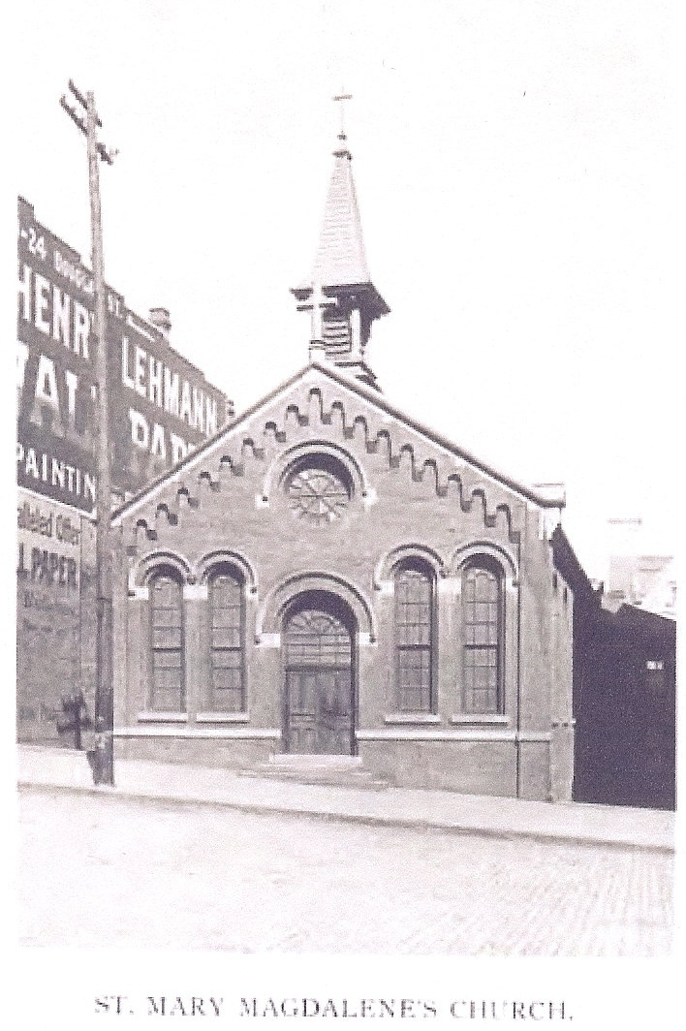
Christina DISCH line

Christina DISCH COLBERT (1832 to 1902)

George SAUTTER (1856 to 1909) (husband of Mary Louisa COLBERT) and their daughter Louise T. SAUTTER (1883 to 1972) and her husband Frank G. HOLMSTEDT (1886 to 1950).

Amelia Henrietta COLBERT McCREARY (1871-1932) (daughter of Christina), her husband Emmet Hughes McCREARY (1872-1932), and their son Emmet Leo McCREARY (1896 to 1938) and their daughter Emma Margaret McCREARY (1910 to 1982).

Brigitte Disch Line

Brigitte DISCH MERGEN (1841 to 1905), her husband, Nicholas MERGEN (1834 to 1908), their infant daughter Lucy Gertrude MERGEN (1874), and their son Philip Peter MERGEN (1867 to 1927).

John Peter MERTES and Anna Therese DISCH line

John Peter MERTES (1835 to 1916) and his wife Marie Therese DISCH (1838 to 1903). Their never-married son Nicholas Peter MERTES (1872 to 1926). Joseph BAUST (1871 to 1933), first husband of their daughter Teresa Frances MERTES.

Anna M MERTES REMER (1870 to 1947), her husband Charles REMER (1864 to 1943), their infant son John REMER (1891), and their son William REMER (1897 to 1968). Edward Otto PRILL (1920 to 1969), grandson of Anna and Charles.

The MERTES Family

by Charles Richard Moore

John Peter MERTES came from Germany as a young man and met his wife Theresa who also was from Germany. I have no way of knowing if they met and married in Omaha or came here as a young married couple. I know that Anna, their youngest daughter, was born here. John MERTES worked at the packing houses. They also ran a boarding house and at one time both John and Theresa cleaned the old Madison school on 166 Madison Street. They had four children: Theresa, Margaret, Anna, and Nicholas.

Theresa (the mother) passed away in 1903 and was laid to rest in Mary Magdalene Cemetery in Omaha. John Peter MERTES went by his second name, Peter, but his proper name is John Peter MERTES as it is on his marker. Peter found it hard to give up the old ways and spoke very little English.

After the death of his wife Theresa in 1903, John Peter moved in with his daugher Anna and family on Z Street. They had lived in a small house just up the hill on Z Street from the Remer Garage. They rented the house for a while and then sold it. Peter did spend some time with his daughter Margaret, but she had a large family so much of his time was at Anna REMER's place. His other daughter, Theresa, moved to California and the boy of the family, Nicholas, never married. While living with Anna, Peter would pass the time by taking the family cow out each day to graze. He would stake the cow and then spend the day and in the afternoon bring the cow home to be milked. He did this and other odd jobs until his health turned bad and they sold the cow. Peter passed away in 1916.

Theresa, their daughter who moved to California, passed away in the early 1960s. Margaret passed away in 1950 and their only son Nicholas passed away in 1926 at 55 years of age. Nicholas is in the family plot with his mother and father. Also, Anna's first two children are on the MERTES plot.

Corrections: Anna was the oldest daughter. John’s wife Therese was an ethnic German but from Alsace, France, not Germany.

The Joseph BAUST Story

by Donald H. MOORE

The following is what was told to me by Charles Richard MOORE in 2001.
It tells the story of the first husband of Teresa Frances MERTES

The MERTES house is on Z street directly across the street from the REMER house. The Joseph BAUST house is next to the REMER house, on the side leading down towards 13th Street. The George BAUST house is the one that was torn down for Mandan Park. Most of the men in the neighborhood worked in the same nearby meat packing houses, including the BAUST men, Karl REMER, and Nicholas MERTES.

Uncles Charles remembers the story as he heard it from his mother who obviously had heard it from her parents or other older family members who were around at the time.

Unlike the other men, Joseph had the habit of coming home at lunch time and apparently not just to eat. One afternoon, Grandma REMER heard Joseph shouting and the family dog madly yelping next door. She yelled out the window asking what was wrong. Joseph shouted back that he was going to kill the #$%@ dog and that as soon as he was done he would come over and kill her. She immediately sent one of the boys running down to the packing house to get the other neighborhood men. The men came and went into Joseph's house to see what was happening. At that point the dog was dead and Joseph was going crazy and attacked them. There were several of them, so they quickly subdued him, although Grandpa Remer got a black eye in the process. Joseph was then taken away to the mental institution. Joseph spent the rest of his life there and was later buried in the MERTES family plot.

Sometime after Joseph had been committed to the instution, Therese formed a relationship with Henry FISHER. Henry was a previous resident of Omaha who had been living in California in 1900. Both Uncle Charles and Teresa’s granddaughter Joanne HEIM DAVIS say that Teresa met Henry before moving to California. The relationship caused a scandal in the family and not everyone was tolerant of the relationship. That was probably made worse by Joseph’s brother George being in the family. But at that time it was impossible to divorce or annul a marriage if one spouse was in a mental institution. According to Charles, Therese moved to California to get away from the intolerant family members.

Memories from Joanne HEIM DAVIS

(Joanne is the daughter of Lydia Christine FISHER and granddaughter of Teresa Frances MERTES. In the story below, Helen was Helen REMER MOORE. Auntie would be Helen’s mother. Anna was Helen’s older sister.)

Yes, my mother and Helen spent time together that winter about 1919. I have a great group picture of all the Remers, Uncle Nick, my grandmother and mother. I think Helen (because she was the baby - and the favorite) she was a little mischievous. Auntie, liked jewelry very much and Helen liked to sneak into her jewelry box and then Anna would get the blame. My mother never told but always wondered why Helen would do that. Also, Auntie would like my mother to make the feather bed up in the morning as she could fluff it up real good. The Baust girls were not allowed to associate with my mother because she was born out of wedlock. My grandmother was still married to Joseph Baust and he was in the asylum. When my grandmother got pregnant with my mother she moved to California. I just found this out a couple of years ago when I started to do the family history. One day in church my mother passed out and Margaret Baust went outside with her to find out what happened. I hear that Margaret was a rebel!

* * *

Also, my grandfather, Henry Martin Fisher, married to Therese Mertes, had a brother named Kearney Siegel Fisher who worked for the Omaha Bee was married to Mary McDonald who had a brother who was a sheriff in Omaha. They lived at 1446 No. 20th Street. What I need to find out is another brother while visiting there died. His name is John Leonard Fisher and he was 45 years old when he died and born about 1851 or 1852. He is buried at Forest Lawn. He probably died around 1897. There was an obit in the Omaha Bee but no date. If you could find a death certificate and can get me the info I'd appreciate it.

* * *

My mother told me that Great-Grandpa Peter Mertes had a brother named Peter John - any truth to this? I know there were other Mertes people living in Omaha and I have seen people on the Social Security index.

